

Global Polyimide Tape (Kapton Tape) Market July, 2020


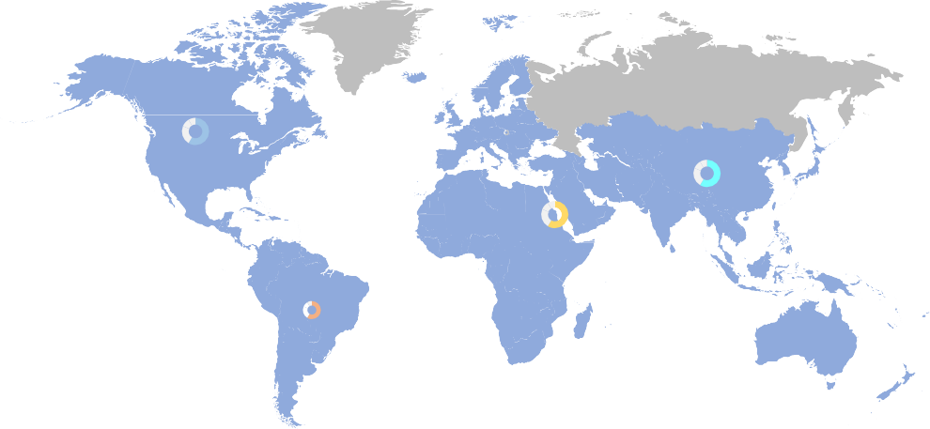







North America
XX.X
US$ Mn
Europe
XX.X
US$ Mn
Middle East &
Africa
XX.X
US$ Mn
Asia-Pacific
XX.X
US$ Mn
South America
XX.X
US$ Mn
Key Points Covered in this report:
- Taxonomy
By Product Type and End-Use
Product Type
Silicone-based
Acrylic-based
End-Use
Aerospace & Defense Automotive Electronics Industrial
Other End-Uses
Consumption and Production
Data by Region
Marketing Strategy, Supply &
Value Chain
Key Player, Distributor &
Supplier Profiles
Market Value & Volume Data by
Product & Region
Cost Structure & Pricing Analysis
Recent Development,
Competitive Analysis and
Company Share Analysis by Region
M a r k e t R e s e a r c h . B i z

M a r k e t R e s e a r c h . B i z
Table of Contents

Chapter 1 Global Polyimide Tape (Kapton Tape) Market Overview
  - Introduction
  - Taxonomy
    - By Product Type & End-Use
    - By Region
  - Drivers for Polyimide Tape (Kapton Tape) Market
  - Restraints for Polyimide Tape (Kapton Tape) Market
  - Opportunities for Polyimide Tape (Kapton Tape) Market
  - Trends for Polyimide Tape (Kapton Tape) Market
  - Macro-economic Factors
  - Regulatory Framework
  - Global Polyimide Tape (Kapton Tape) Market Pricing Analysis by Region, 2020
  - Opportunity Map Analysis
  - Oppurtunity Orbits
  - Market Investment Feasibility Index
  - PEST Analysis
  - PORTER’S Five Force Analysis
  - Drivers & Restraints Impact Analysis
  - Marketing Strategy
  - List of Buyers in USA, Mexico, and Latin America
  - Industry Chain Analysis
  - Cost Structure Analysis
  - Regional Market Share and BPS Analysis in Polyimide Tape (Kapton Tape) Market Chapter 2 Global Polyimide Tape (Kapton Tape) Market Overview
  - Global Polyimide Tape (Kapton Tape) Market Value & Volume Comparison by Product Type (2014-2030)
  - Global Polyimide Tape (Kapton Tape) Market by End-Use
  - Global Polyimide Tape (Kapton Tape) Market Outlook by Region
  - Global Polyimide Tape (Kapton Tape) Market Outlook (2014-2030)
  - Global Polyimide Tape (Kapton Tape) Market Value & Volume by Regions
  - Global Polyimide Tape (Kapton Tape) Market Value & Volume by Product Type
  - Global Polyimide Tape (Kapton Tape) Market Value & Volume by End-Use
  - Global Polyimide Tape (Kapton Tape) Market Y-o-Y Growth Rate Comparison 2015– 2030
  - Global Polyimide Tape (Kapton Tape) Market Share Comparison 2014–2030 Chapter 3 North America Polyimide Tape (Kapton Tape) Market Overview
  - North America Polyimide Tape (Kapton Tape) Market by Product Type

M a r k e t R e s e a r c h . B i z

  - North America Polyimide Tape (Kapton Tape) Market by End-Use
  - North America Polyimide Tape (Kapton Tape) Market Outlook by Region
  - North America Polyimide Tape (Kapton Tape) Market Outlook (2014-2030)
  - North America Polyimide Tape (Kapton Tape) Market Value & Volume by Regions
  - North America Polyimide Tape (Kapton Tape) Market Value & Volume by Product Type
  - North America Polyimide Tape (Kapton Tape) Market Value & Volume by End-Use
  - North America Polyimide Tape (Kapton Tape) Market Y-o-Y Growth Rate Comparison 2015–2030
  - North America Polyimide Tape (Kapton Tape) Market Share Comparison 2014–2030 Chapter 4 Europe Polyimide Tape (Kapton Tape) Market Overview
  - Europe Polyimide Tape (Kapton Tape) Market by Product Type
  - Europe Polyimide Tape (Kapton Tape) Market by End-Use
  - Europe Polyimide Tape (Kapton Tape) Market Outlook by Region
  - Europe Polyimide Tape (Kapton Tape) Market Outlook (2014-2030)
  - Europe Polyimide Tape (Kapton Tape) Market Value & Volume by Regions
  - Europe Polyimide Tape (Kapton Tape) Market Value & Volume by Product Type
  - Europe Polyimide Tape (Kapton Tape) Market Value & Volume by End-Use
  - Europe Polyimide Tape (Kapton Tape) Market Y-o-Y Growth Rate Comparison 2015– 2030
  - Europe Polyimide Tape (Kapton Tape) Market Share Comparison 2014–2030 Chapter 5 Asia-Pacific Polyimide Tape (Kapton Tape) Market Overview
  - Asia-Pacific Polyimide Tape (Kapton Tape) Market by Product Type
  - Asia-Pacific Polyimide Tape (Kapton Tape) Market by End-Use
  - Asia-Pacific Polyimide Tape (Kapton Tape) Market Outlook by Region
  - Asia-Pacific Polyimide Tape (Kapton Tape) Market Outlook (2014-2030)
  - Asia-Pacific Polyimide Tape (Kapton Tape) Market Value & Volume by Regions
  - Asia-Pacific Polyimide Tape (Kapton Tape) Market Value & Volume by Product Type
  - Asia-Pacific Polyimide Tape (Kapton Tape) Market Value & Volume by End-Use
  - Asia-Pacific Polyimide Tape (Kapton Tape) Market Y-o-Y Growth Rate Comparison 2015–2030
  - Asia-Pacific Polyimide Tape (Kapton Tape) Market Share Comparison 2014–2030 Chapter 6 South America Polyimide Tape (Kapton Tape) Market Overview
  - South America Polyimide Tape (Kapton Tape) Market by Product Type
  - South America Polyimide Tape (Kapton Tape) Market by End-Use
  - South America Polyimide Tape (Kapton Tape) Market Outlook by Region
  - South America Polyimide Tape (Kapton Tape) Market Outlook (2014-2030)
  - South America Polyimide Tape (Kapton Tape) Market Value & Volume by Regions
  - South America Polyimide Tape (Kapton Tape) Market Value & Volume by Product Type

M a r k e t R e s e a r c h . B i z

  - South America Polyimide Tape (Kapton Tape) Market Value & Volume by End-Use
  - South America Polyimide Tape (Kapton Tape) Market Y-o-Y Growth Rate Comparison 2015–2030
  - South America Polyimide Tape (Kapton Tape) Market Share Comparison 2014–2030 Chapter 7 MEA Polyimide Tape (Kapton Tape) Market Overview
  - MEA Polyimide Tape (Kapton Tape) Market by Product Type
  - MEA Polyimide Tape (Kapton Tape) Market by End-Use
  - MEA Polyimide Tape (Kapton Tape) Market Outlook by Region
  - MEA Polyimide Tape (Kapton Tape) Market Outlook (2014-2030)
  - MEA Polyimide Tape (Kapton Tape) Market Value & Volume by Regions
  - MEA Polyimide Tape (Kapton Tape) Market Value & Volume by Product Type
  - MEA Polyimide Tape (Kapton Tape) Market Value & Volume by End-Use
  - MEA Polyimide Tape (Kapton Tape) Market Y-o-Y Growth Rate Comparison 2015–2030
  - MEA Polyimide Tape (Kapton Tape) Market Share Comparison 2014–2030 Chapter 8 Global Polyimide Tape (Kapton Tape) Market Company Profiles
  - Market Competition Scenario Analysis, By Company
  - Competitor Landscape
  - Company Share Analysis
  - Company Profiles
    - 3M Company
      - Company Overview
      - Business Description
      - Product Portfolio
      - Key Financials
      - Key Developments
    - Botron Company Inc.
    - CanDo National Tape
    - E.l. du Pont de Nemours and Company
    - Nitto Denko Corporation
    - Polyonics Inc.
    - Desco Industries
    - Chukoh Chemical Industries, Ltd.
    - DUNMORE
    - ESPI
    - Other Key Players
Chapter 9 Research Methodology
  - Research Methodology
  - Primary Research

M a r k e t R e s e a r c h . B i z

  - Secondary Research
9.3 Report Scope Chapter 10 About Us
9.1 Who we are

M a r k e t R e s e a r c h . B i z
List of Figures

FIG. 1 Global Polyimide Tape (Kapton Tape) Market Value & Volume Market Share by Product Type in 2020
FIG. 2 Global Polyimide Tape (Kapton Tape) Market Attractiveness Analysis by Product Type, 2014–2021
FIG. 3 Global Polyimide Tape (Kapton Tape) Market Value & Volume Market Share by End-Use in 2020
FIG. 4 Global Polyimide Tape (Kapton Tape) Market Attractiveness Analysis by End-Use, 2014– 2021
FIG. 5 Global Polyimide Tape (Kapton Tape) Market Value & Volume Market Share by Region in 2020
FIG. 6 Global Polyimide Tape (Kapton Tape) Market Attractiveness Analysis by Region, 2014–2021 FIG. 7 Global Polyimide Tape (Kapton Tape) Market Value & Volume (2014–2021)
FIG. 8 Global Polyimide Tape (Kapton Tape) Market Value & Volume (2022-2030)
FIG. 9 Global Polyimide Tape (Kapton Tape) Market Value & Volume Comparison by Region (2014– 2021)
FIG. 10 Global Polyimide Tape (Kapton Tape) Market Value & Volume Comparison by Region (2022- 2030)
FIG. 11 Global Polyimide Tape (Kapton Tape) Market Value & Volume Comparison by Product Type (2014–2021)
FIG. 12 Global Polyimide Tape (Kapton Tape) Market Value & Volume Comparison by Product Type (2022-2030)
FIG. 13 Global Polyimide Tape (Kapton Tape) Market Value & Volume Comparison by End-Use (2014–2021)
FIG. 14 Global Polyimide Tape (Kapton Tape) Market Value & Volume Comparison by End-Use (2022-2030)
FIG. 15 Global Polyimide Tape (Kapton Tape) Market Y-o-Y Growth Rate Comparison by Region (2015-2021)
FIG. 16 Global Polyimide Tape (Kapton Tape) Market Y-o-Y Growth Rate Comparison by Region (2022-2030)
FIG. 17 Global Polyimide Tape (Kapton Tape) Market Y-o-Y Growth Rate Comparison by Product Type (2015-2021)
FIG. 18 Global Polyimide Tape (Kapton Tape) Market Y-o-Y Growth Rate Comparison by Product Type (2022-2030)
FIG. 19 Global Polyimide Tape (Kapton Tape) Market Y-o-Y Growth Rate Comparison by End-Use (2015-2021)
FIG. 20 Global Polyimide Tape (Kapton Tape) Market Y-o-Y Growth Rate Comparison by End-Use (2022-2030)
FIG. 21 Global Polyimide Tape (Kapton Tape) Market Share Comparison by Region (2014–2021) FIG. 22 Global Polyimide Tape (Kapton Tape) Market Share Comparison by Region (2022-2030)

M a r k e t R e s e a r c h . B i z

FIG. 23 Global Polyimide Tape (Kapton Tape) Market Share Comparison by Product Type (2014– 2021)
FIG. 24 Global Polyimide Tape (Kapton Tape) Market Share Comparison by Product Type (2022- 2030)
FIG. 25 Global Polyimide Tape (Kapton Tape) Market Share Comparison by End-Use (2014–2021) FIG. 26 Global Polyimide Tape (Kapton Tape) Market Share Comparison by End-Use (2022-2030)
FIG. 27 North America Polyimide Tape (Kapton Tape) Market Value & Volume Market Share by Product Type in 2020
FIG. 28 North America Polyimide Tape (Kapton Tape) Market Attractiveness Analysis by Product Type, 2014–2021
FIG. 29 North America Polyimide Tape (Kapton Tape) Market Value & Volume Market Share by End- Use in 2020
FIG. 30 North America Polyimide Tape (Kapton Tape) Market Attractiveness Analysis by End-Use, 2014–2021
FIG. 31 North America Polyimide Tape (Kapton Tape) Market Value & Volume Market Share by Region in 2020
FIG. 32 North America Polyimide Tape (Kapton Tape) Market Attractiveness Analysis by Region, 2014–2021
FIG. 33 North America Polyimide Tape (Kapton Tape) Market Value & Volume (2014–2021) FIG. 34 North America Polyimide Tape (Kapton Tape) Market Value & Volume (2022-2030)
FIG. 35 North America Polyimide Tape (Kapton Tape) Market Value & Volume Comparison by Region (2014–2021)
FIG. 36 North America Polyimide Tape (Kapton Tape) Market Value & Volume Comparison by Region (2022-2030)
FIG. 37 North America Polyimide Tape (Kapton Tape) Market Value & Volume Comparison by Product Type (2014–2021)
FIG. 38 North America Polyimide Tape (Kapton Tape) Market Value & Volume Comparison by Product Type (2022-2030)
FIG. 39 North America Polyimide Tape (Kapton Tape) Market Value & Volume Comparison by End- Use (2014–2021)
FIG. 40 North America Polyimide Tape (Kapton Tape) Market Value & Volume Comparison by End- Use (2022-2030)
FIG. 41 North America Polyimide Tape (Kapton Tape) Market Y-o-Y Growth Rate Comparison by Region (2015-2021)
FIG. 42 North America Polyimide Tape (Kapton Tape) Market Y-o-Y Growth Rate Comparison by Region (2022-2030)
FIG. 43 North America Polyimide Tape (Kapton Tape) Market Y-o-Y Growth Rate Comparison by Product Type (2015-2021)
FIG. 44 North America Polyimide Tape (Kapton Tape) Market Y-o-Y Growth Rate Comparison by Product Type (2022-2030)
FIG. 45 North America Polyimide Tape (Kapton Tape) Market Y-o-Y Growth Rate Comparison by End-Use (2015-2021)

M a r k e t R e s e a r c h . B i z

FIG. 46 North America Polyimide Tape (Kapton Tape) Market Y-o-Y Growth Rate Comparison by End-Use (2022-2030)
FIG. 47 North America Polyimide Tape (Kapton Tape) Market Share Comparison by Region (2014– 2021)
FIG. 48 North America Polyimide Tape (Kapton Tape) Market Share Comparison by Region (2022- 2030)
FIG. 49 North America Polyimide Tape (Kapton Tape) Market Share Comparison by Product Type (2014–2021)
FIG. 50 North America Polyimide Tape (Kapton Tape) Market Share Comparison by Product Type (2022-2030)
FIG. 51 North America Polyimide Tape (Kapton Tape) Market Share Comparison by End-Use (2014– 2021)
FIG. 52 North America Polyimide Tape (Kapton Tape) Market Share Comparison by End-Use (2022- 2030)
FIG. 53 Europe Polyimide Tape (Kapton Tape) Market Value & Volume Market Share by Product Type in 2020
FIG. 54 Europe Polyimide Tape (Kapton Tape) Market Attractiveness Analysis by Product Type, 2014–2021
FIG. 55 Europe Polyimide Tape (Kapton Tape) Market Value & Volume Market Share by End-Use in 2020
FIG. 56 Europe Polyimide Tape (Kapton Tape) Market Attractiveness Analysis by End-Use, 2014– 2021
FIG. 57 Europe Polyimide Tape (Kapton Tape) Market Value & Volume Market Share by Region in 2020
FIG. 58 Europe Polyimide Tape (Kapton Tape) Market Attractiveness Analysis by Region, 2014–2021 FIG. 59 Europe Polyimide Tape (Kapton Tape) Market Value & Volume (2014–2021)
FIG. 60 Europe Polyimide Tape (Kapton Tape) Market Value & Volume (2022-2030)
FIG. 61 Europe Polyimide Tape (Kapton Tape) Market Value & Volume Comparison by Region (2014–2021)
FIG. 62 Europe Polyimide Tape (Kapton Tape) Market Value & Volume Comparison by Region (2022- 2030)
FIG. 63 Europe Polyimide Tape (Kapton Tape) Market Value & Volume Comparison by Product Type (2014–2021)
FIG. 64 Europe Polyimide Tape (Kapton Tape) Market Value & Volume Comparison by Product Type (2022-2030)
FIG. 65 Europe Polyimide Tape (Kapton Tape) Market Value & Volume Comparison by End-Use (2014–2021)
FIG. 66 Europe Polyimide Tape (Kapton Tape) Market Value & Volume Comparison by End-Use (2022-2030)
FIG. 67 Europe Polyimide Tape (Kapton Tape) Market Y-o-Y Growth Rate Comparison by Region (2015-2021)

M a r k e t R e s e a r c h . B i z

FIG. 68 Europe Polyimide Tape (Kapton Tape) Market Y-o-Y Growth Rate Comparison by Region (2022-2030)
FIG. 69 Europe Polyimide Tape (Kapton Tape) Market Y-o-Y Growth Rate Comparison by Product Type (2015-2021)
FIG. 70 Europe Polyimide Tape (Kapton Tape) Market Y-o-Y Growth Rate Comparison by Product Type (2022-2030)
FIG. 71 Europe Polyimide Tape (Kapton Tape) Market Y-o-Y Growth Rate Comparison by End-Use (2015-2021)
FIG. 72 Europe Polyimide Tape (Kapton Tape) Market Y-o-Y Growth Rate Comparison by End-Use (2022-2030)
FIG. 73 Europe Polyimide Tape (Kapton Tape) Market Share Comparison by Region (2014–2021)
FIG. 74 Europe Polyimide Tape (Kapton Tape) Market Share Comparison by Region (2022-2030) FIG. 75 Europe Polyimide Tape (Kapton Tape) Market Share Comparison by Product Type (2014–
2021)
FIG. 76 Europe Polyimide Tape (Kapton Tape) Market Share Comparison by Product Type (2022- 2030)
FIG. 77 Europe Polyimide Tape (Kapton Tape) Market Share Comparison by End-Use (2014–2021)
FIG. 78 Europe Polyimide Tape (Kapton Tape) Market Share Comparison by End-Use (2022-2030) FIG. 79 Asia-Pacific Polyimide Tape (Kapton Tape) Market Value & Volume Market Share by Product
Type in 2020
FIG. 80 Asia-Pacific Polyimide Tape (Kapton Tape) Market Attractiveness Analysis by Product Type, 2014–2021
FIG. 81 Asia-Pacific Polyimide Tape (Kapton Tape) Market Value & Volume Market Share by End-Use in 2020
FIG. 82 Asia-Pacific Polyimide Tape (Kapton Tape) Market Attractiveness Analysis by End-Use, 2014–2021
FIG. 83 Asia-Pacific Polyimide Tape (Kapton Tape) Market Value & Volume Market Share by Region in 2020
FIG. 84 Asia-Pacific Polyimide Tape (Kapton Tape) Market Attractiveness Analysis by Region, 2014– 2021
FIG. 85 Asia-Pacific Polyimide Tape (Kapton Tape) Market Value & Volume (2014–2021) FIG. 86 Asia-Pacific Polyimide Tape (Kapton Tape) Market Value & Volume (2022-2030)
FIG. 87 Asia-Pacific Polyimide Tape (Kapton Tape) Market Value & Volume Comparison by Region (2014–2021)
FIG. 88 Asia-Pacific Polyimide Tape (Kapton Tape) Market Value & Volume Comparison by Region (2022-2030)
FIG. 89 Asia-Pacific Polyimide Tape (Kapton Tape) Market Value & Volume Comparison by Product Type (2014–2021)
FIG. 90 Asia-Pacific Polyimide Tape (Kapton Tape) Market Value & Volume Comparison by Product Type (2022-2030)
FIG. 91 Asia-Pacific Polyimide Tape (Kapton Tape) Market Value & Volume Comparison by End-Use (2014–2021)

M a r k e t R e s e a r c h . B i z

FIG. 92 Asia-Pacific Polyimide Tape (Kapton Tape) Market Value & Volume Comparison by End-Use (2022-2030)
FIG. 93 Asia-Pacific Polyimide Tape (Kapton Tape) Market Y-o-Y Growth Rate Comparison by Region (2015-2021)
FIG. 94 Asia-Pacific Polyimide Tape (Kapton Tape) Market Y-o-Y Growth Rate Comparison by Region (2022-2030)
FIG. 95 Asia-Pacific Polyimide Tape (Kapton Tape) Market Y-o-Y Growth Rate Comparison by Product Type (2015-2021)
FIG. 96 Asia-Pacific Polyimide Tape (Kapton Tape) Market Y-o-Y Growth Rate Comparison by Product Type (2022-2030)
FIG. 97 Asia-Pacific Polyimide Tape (Kapton Tape) Market Y-o-Y Growth Rate Comparison by End- Use (2015-2021)
FIG. 98 Asia-Pacific Polyimide Tape (Kapton Tape) Market Y-o-Y Growth Rate Comparison by End- Use (2022-2030)
FIG. 99 Asia-Pacific Polyimide Tape (Kapton Tape) Market Share Comparison by Region (2014– 2021)
FIG. 100 Asia-Pacific Polyimide Tape (Kapton Tape) Market Share Comparison by Region (2022-2030)
FIG. 101 Asia-Pacific Polyimide Tape (Kapton Tape) Market Share Comparison by Product Type (2014–2021)
FIG. 102 Asia-Pacific Polyimide Tape (Kapton Tape) Market Share Comparison by Product Type (2022-2030)
FIG. 103 Asia-Pacific Polyimide Tape (Kapton Tape) Market Share Comparison by End-Use (2014– 2021)
FIG. 104 Asia-Pacific Polyimide Tape (Kapton Tape) Market Share Comparison by End-Use (2022- 2030)
FIG. 105 South America Polyimide Tape (Kapton Tape) Market Value & Volume Market Share by Product Type in 2020
FIG. 106 South America Polyimide Tape (Kapton Tape) Market Attractiveness Analysis by Product Type, 2014–2021
FIG. 107 South America Polyimide Tape (Kapton Tape) Market Value & Volume Market Share by End- Use in 2020
FIG. 108 South America Polyimide Tape (Kapton Tape) Market Attractiveness Analysis by End-Use, 2014–2021
FIG. 109 South America Polyimide Tape (Kapton Tape) Market Value & Volume Market Share by Region in 2020
FIG. 110 South America Polyimide Tape (Kapton Tape) Market Attractiveness Analysis by Region, 2014–2021
FIG. 111 South America Polyimide Tape (Kapton Tape) Market Value & Volume (2014–2021)
FIG. 112 South America Polyimide Tape (Kapton Tape) Market Value & Volume (2022-2030) FIG. 113 South America Polyimide Tape (Kapton Tape) Market Value & Volume Comparison by
Region (2014–2021)

M a r k e t R e s e a r c h . B i z

FIG. 114 South America Polyimide Tape (Kapton Tape) Market Value & Volume Comparison by Region (2022-2030)
FIG. 115 South America Polyimide Tape (Kapton Tape) Market Value & Volume Comparison by Product Type (2014–2021)
FIG. 116 South America Polyimide Tape (Kapton Tape) Market Value & Volume Comparison by Product Type (2022-2030)
FIG. 117 South America Polyimide Tape (Kapton Tape) Market Value & Volume Comparison by End- Use (2014–2021)
FIG. 118 South America Polyimide Tape (Kapton Tape) Market Value & Volume Comparison by End- Use (2022-2030)
FIG. 119 South America Polyimide Tape (Kapton Tape) Market Y-o-Y Growth Rate Comparison by Region (2015-2021)
FIG. 120 South America Polyimide Tape (Kapton Tape) Market Y-o-Y Growth Rate Comparison by Region (2022-2030)
FIG. 121 South America Polyimide Tape (Kapton Tape) Market Y-o-Y Growth Rate Comparison by Product Type (2015-2021)
FIG. 122 South America Polyimide Tape (Kapton Tape) Market Y-o-Y Growth Rate Comparison by Product Type (2022-2030)
FIG. 123 South America Polyimide Tape (Kapton Tape) Market Y-o-Y Growth Rate Comparison by End-Use (2015-2021)
FIG. 124 South America Polyimide Tape (Kapton Tape) Market Y-o-Y Growth Rate Comparison by End-Use (2022-2030)
FIG. 125 South America Polyimide Tape (Kapton Tape) Market Share Comparison by Region (2014– 2021)
FIG. 126 South America Polyimide Tape (Kapton Tape) Market Share Comparison by Region (2022- 2030)
FIG. 127 South America Polyimide Tape (Kapton Tape) Market Share Comparison by Product Type (2014–2021)
FIG. 128 South America Polyimide Tape (Kapton Tape) Market Share Comparison by Product Type (2022-2030)
FIG. 129 South America Polyimide Tape (Kapton Tape) Market Share Comparison by End-Use (2014– 2021)
FIG. 130 South America Polyimide Tape (Kapton Tape) Market Share Comparison by End-Use (2022- 2030)
FIG. 131 MEA Polyimide Tape (Kapton Tape) Market Value & Volume Market Share by Product Type in 2020
FIG. 132 MEA Polyimide Tape (Kapton Tape) Market Attractiveness Analysis by Product Type, 2014– 2021
FIG. 133 MEA Polyimide Tape (Kapton Tape) Market Value & Volume Market Share by End-Use in 2020
FIG. 134 MEA Polyimide Tape (Kapton Tape) Market Attractiveness Analysis by End-Use, 2014–2021 FIG. 135 MEA Polyimide Tape (Kapton Tape) Market Value & Volume Market Share by Region in 2020

M a r k e t R e s e a r c h . B i z

FIG. 136 MEA Polyimide Tape (Kapton Tape) Market Attractiveness Analysis by Region, 2014–2021 FIG. 137 MEA Polyimide Tape (Kapton Tape) Market Value & Volume (2014–2021)
FIG. 138 MEA Polyimide Tape (Kapton Tape) Market Value & Volume (2022-2030)
FIG. 139 MEA Polyimide Tape (Kapton Tape) Market Value & Volume Comparison by Region (2014– 2021)
FIG. 140 MEA Polyimide Tape (Kapton Tape) Market Value & Volume Comparison by Region (2022- 2030)
FIG. 141 MEA Polyimide Tape (Kapton Tape) Market Value & Volume Comparison by Product Type (2014–2021)
FIG. 142 MEA Polyimide Tape (Kapton Tape) Market Value & Volume Comparison by Product Type (2022-2030)
FIG. 143 MEA Polyimide Tape (Kapton Tape) Market Value & Volume Comparison by End-Use (2014– 2021)
FIG. 144 MEA Polyimide Tape (Kapton Tape) Market Value & Volume Comparison by End-Use (2022- 2030)
FIG. 145 MEA Polyimide Tape (Kapton Tape) Market Y-o-Y Growth Rate Comparison by Region (2015- 2021)
FIG. 146 MEA Polyimide Tape (Kapton Tape) Market Y-o-Y Growth Rate Comparison by Region (2022- 2030)
FIG. 147 MEA Polyimide Tape (Kapton Tape) Market Y-o-Y Growth Rate Comparison by Product Type (2015-2021)
FIG. 148 MEA Polyimide Tape (Kapton Tape) Market Y-o-Y Growth Rate Comparison by Product Type (2022-2030)
FIG. 149 MEA Polyimide Tape (Kapton Tape) Market Y-o-Y Growth Rate Comparison by End-Use (2015-2021)
FIG. 150 MEA Polyimide Tape (Kapton Tape) Market Y-o-Y Growth Rate Comparison by End-Use (2022-2030)
FIG. 151 MEA Polyimide Tape (Kapton Tape) Market Share Comparison by Region (2014–2021) FIG. 152 MEA Polyimide Tape (Kapton Tape) Market Share Comparison by Region (2022-2030)
FIG. 153 MEA Polyimide Tape (Kapton Tape) Market Share Comparison by Product Type (2014–2021) FIG. 154 MEA Polyimide Tape (Kapton Tape) Market Share Comparison by Product Type (2022-2030) FIG. 155 MEA Polyimide Tape (Kapton Tape) Market Share Comparison by End-Use (2014–2021)
FIG. 156 MEA Polyimide Tape (Kapton Tape) Market Share Comparison by End-Use (2022-2030)

M a r k e t R e s e a r c h . B i z

List of Tables

Global Polyimide Tape (Kapton Tape) Market Comparison by Product Type (2014-2030) Global Polyimide Tape (Kapton Tape) Market Comparison by End-Use (2014-2030)
Global Polyimide Tape (Kapton Tape) Market Value & Volume Comparison by Region (2014- 2030)
Global Polyimide Tape (Kapton Tape) Market Value & Volume (2014–2021) Global Polyimide Tape (Kapton Tape) Market Value & Volume (2022-2030)
Global Polyimide Tape (Kapton Tape) Market Value & Volume Comparison by Region (2014– 2021)
Global Polyimide Tape (Kapton Tape) Market Value & Volume Comparison by Region (2022- 2030)
Global Polyimide Tape (Kapton Tape) Market Value & Volume Comparison by Product Type (2014–2021)
Global Polyimide Tape (Kapton Tape) Market Value & Volume Comparison by Product Type (2022-2030)
Global Polyimide Tape (Kapton Tape) Market Value & Volume Comparison by End-Use (2014–2021)
Global Polyimide Tape (Kapton Tape) Market Value & Volume Comparison by End-Use (2022-2030)
Global Polyimide Tape (Kapton Tape) Market Y-o-Y Growth Rate Comparison by Region (2015-2021)
Global Polyimide Tape (Kapton Tape) Market Y-o-Y Growth Rate Comparison by Region (2022-2030)
Global Polyimide Tape (Kapton Tape) Market Y-o-Y Growth Rate Comparison by Product Type (2015-2021)
Global Polyimide Tape (Kapton Tape) Market Y-o-Y Growth Rate Comparison by Product Type (2022-2030)
Global Polyimide Tape (Kapton Tape) Market Y-o-Y Growth Rate Comparison by End-Use (2015-2021)
Global Polyimide Tape (Kapton Tape) Market Y-o-Y Growth Rate Comparison by End-Use (2022-2030)
Global Polyimide Tape (Kapton Tape) Market Share Comparison by Region (2014–2021)
Global Polyimide Tape (Kapton Tape) Market Share Comparison by Region (2022-2030)
Global Polyimide Tape (Kapton Tape) Market Share Comparison by Product Type (2014– 2021)
Global Polyimide Tape (Kapton Tape) Market Share Comparison by Product Type (2022- 2030)
Global Polyimide Tape (Kapton Tape) Market Share Comparison by End-Use (2014–2021) Global Polyimide Tape (Kapton Tape) Market Share Comparison by End-Use (2022-2030)

M a r k e t R e s e a r c h . B i z

North America Polyimide Tape (Kapton Tape) Market Comparison by Product Type (2014- 2030)
North America Polyimide Tape (Kapton Tape) Market Comparison by End-Use (2014-2030)
North America Polyimide Tape (Kapton Tape) Market Value & Volume Comparison by Region (2014-2030)
North America Polyimide Tape (Kapton Tape) Market Value & Volume (2014–2021) North America Polyimide Tape (Kapton Tape) Market Value & Volume (2022-2030)
North America Polyimide Tape (Kapton Tape) Market Value & Volume Comparison by Region (2014–2021)
North America Polyimide Tape (Kapton Tape) Market Value & Volume Comparison by Region (2022-2030)
North America Polyimide Tape (Kapton Tape) Market Value & Volume Comparison by Product Type (2014–2021)
North America Polyimide Tape (Kapton Tape) Market Value & Volume Comparison by Product Type (2022-2030)
North America Polyimide Tape (Kapton Tape) Market Value & Volume Comparison by End- Use (2014–2021)
North America Polyimide Tape (Kapton Tape) Market Value & Volume Comparison by End- Use (2022-2030)
North America Polyimide Tape (Kapton Tape) Market Y-o-Y Growth Rate Comparison by Region (2015-2021)
North America Polyimide Tape (Kapton Tape) Market Y-o-Y Growth Rate Comparison by Region (2022-2030)
North America Polyimide Tape (Kapton Tape) Market Y-o-Y Growth Rate Comparison by Product Type (2015-2021)
North America Polyimide Tape (Kapton Tape) Market Y-o-Y Growth Rate Comparison by Product Type (2022-2030)
North America Polyimide Tape (Kapton Tape) Market Y-o-Y Growth Rate Comparison by End-Use (2015-2021)
North America Polyimide Tape (Kapton Tape) Market Y-o-Y Growth Rate Comparison by End-Use (2022-2030)
North America Polyimide Tape (Kapton Tape) Market Share Comparison by Region (2014– 2021)
North America Polyimide Tape (Kapton Tape) Market Share Comparison by Region (2022- 2030)
North America Polyimide Tape (Kapton Tape) Market Share Comparison by Product Type (2014–2021)
North America Polyimide Tape (Kapton Tape) Market Share Comparison by Product Type (2022-2030)
North America Polyimide Tape (Kapton Tape) Market Share Comparison by End-Use (2014– 2021)

M a r k e t R e s e a r c h . B i z

North America Polyimide Tape (Kapton Tape) Market Share Comparison by End-Use (2022- 2030)
Europe Polyimide Tape (Kapton Tape) Market Comparison by Product Type (2014-2030) Europe Polyimide Tape (Kapton Tape) Market Comparison by End-Use (2014-2030)
Europe Polyimide Tape (Kapton Tape) Market Value & Volume Comparison by Region (2014- 2030)
Europe Polyimide Tape (Kapton Tape) Market Value & Volume (2014–2021) Europe Polyimide Tape (Kapton Tape) Market Value & Volume (2022-2030)
Europe Polyimide Tape (Kapton Tape) Market Value & Volume Comparison by Region (2014–2021)
Europe Polyimide Tape (Kapton Tape) Market Value & Volume Comparison by Region (2022- 2030)
Europe Polyimide Tape (Kapton Tape) Market Value & Volume Comparison by Product Type (2014–2021)
Europe Polyimide Tape (Kapton Tape) Market Value & Volume Comparison by Product Type (2022-2030)
Europe Polyimide Tape (Kapton Tape) Market Value & Volume Comparison by End-Use (2014–2021)
Europe Polyimide Tape (Kapton Tape) Market Value & Volume Comparison by End-Use (2022-2030)
Europe Polyimide Tape (Kapton Tape) Market Y-o-Y Growth Rate Comparison by Region (2015-2021)
Europe Polyimide Tape (Kapton Tape) Market Y-o-Y Growth Rate Comparison by Region (2022-2030)
Europe Polyimide Tape (Kapton Tape) Market Y-o-Y Growth Rate Comparison by Product Type (2015-2021)
Europe Polyimide Tape (Kapton Tape) Market Y-o-Y Growth Rate Comparison by Product Type (2022-2030)
Europe Polyimide Tape (Kapton Tape) Market Y-o-Y Growth Rate Comparison by End-Use (2015-2021)
Europe Polyimide Tape (Kapton Tape) Market Y-o-Y Growth Rate Comparison by End-Use (2022-2030)
Europe Polyimide Tape (Kapton Tape) Market Share Comparison by Region (2014–2021)
Europe Polyimide Tape (Kapton Tape) Market Share Comparison by Region (2022-2030)
Europe Polyimide Tape (Kapton Tape) Market Share Comparison by Product Type (2014– 2021)
Europe Polyimide Tape (Kapton Tape) Market Share Comparison by Product Type (2022- 2030)
Europe Polyimide Tape (Kapton Tape) Market Share Comparison by End-Use (2014–2021) Europe Polyimide Tape (Kapton Tape) Market Share Comparison by End-Use (2022-2030) Asia-Pacific Polyimide Tape (Kapton Tape) Market Comparison by Product Type (2014-2030)

M a r k e t R e s e a r c h . B i z

Asia-Pacific Polyimide Tape (Kapton Tape) Market Comparison by End-Use (2014-2030)
Asia-Pacific Polyimide Tape (Kapton Tape) Market Value & Volume Comparison by Region (2014-2030)
Asia-Pacific Polyimide Tape (Kapton Tape) Market Value & Volume (2014–2021) Asia-Pacific Polyimide Tape (Kapton Tape) Market Value & Volume (2022-2030)
Asia-Pacific Polyimide Tape (Kapton Tape) Market Value & Volume Comparison by Region (2014–2021)
Asia-Pacific Polyimide Tape (Kapton Tape) Market Value & Volume Comparison by Region (2022-2030)
Asia-Pacific Polyimide Tape (Kapton Tape) Market Value & Volume Comparison by Product Type (2014–2021)
Asia-Pacific Polyimide Tape (Kapton Tape) Market Value & Volume Comparison by Product Type (2022-2030)
Asia-Pacific Polyimide Tape (Kapton Tape) Market Value & Volume Comparison by End-Use (2014–2021)
Asia-Pacific Polyimide Tape (Kapton Tape) Market Value & Volume Comparison by End-Use (2022-2030)
Asia-Pacific Polyimide Tape (Kapton Tape) Market Y-o-Y Growth Rate Comparison by Region (2015-2021)
Asia-Pacific Polyimide Tape (Kapton Tape) Market Y-o-Y Growth Rate Comparison by Region (2022-2030)
Asia-Pacific Polyimide Tape (Kapton Tape) Market Y-o-Y Growth Rate Comparison by Product Type (2015-2021)
Asia-Pacific Polyimide Tape (Kapton Tape) Market Y-o-Y Growth Rate Comparison by Product Type (2022-2030)
Asia-Pacific Polyimide Tape (Kapton Tape) Market Y-o-Y Growth Rate Comparison by End- Use (2015-2021)
Asia-Pacific Polyimide Tape (Kapton Tape) Market Y-o-Y Growth Rate Comparison by End- Use (2022-2030)
Asia-Pacific Polyimide Tape (Kapton Tape) Market Share Comparison by Region (2014– 2021)
Asia-Pacific Polyimide Tape (Kapton Tape) Market Share Comparison by Region (2022-2030)
Asia-Pacific Polyimide Tape (Kapton Tape) Market Share Comparison by Product Type (2014–2021)
Asia-Pacific Polyimide Tape (Kapton Tape) Market Share Comparison by Product Type (2022-2030)
Asia-Pacific Polyimide Tape (Kapton Tape) Market Share Comparison by End-Use (2014– 2021)
Asia-Pacific Polyimide Tape (Kapton Tape) Market Share Comparison by End-Use (2022- 2030)
South America Polyimide Tape (Kapton Tape) Market Comparison by Product Type (2014- 2030)

M a r k e t R e s e a r c h . B i z

South America Polyimide Tape (Kapton Tape) Market Comparison by End-Use (2014-2030)
South America Polyimide Tape (Kapton Tape) Market Value & Volume Comparison by Region (2014-2030)
South America Polyimide Tape (Kapton Tape) Market Value & Volume (2014–2021) South America Polyimide Tape (Kapton Tape) Market Value & Volume (2022-2030)
South America Polyimide Tape (Kapton Tape) Market Value & Volume Comparison by Region (2014–2021)
South America Polyimide Tape (Kapton Tape) Market Value & Volume Comparison by Region (2022-2030)
South America Polyimide Tape (Kapton Tape) Market Value & Volume Comparison by Product Type (2014–2021)
South America Polyimide Tape (Kapton Tape) Market Value & Volume Comparison by Product Type (2022-2030)
South America Polyimide Tape (Kapton Tape) Market Value & Volume Comparison by End- Use (2014–2021)
South America Polyimide Tape (Kapton Tape) Market Value & Volume Comparison by End- Use (2022-2030)
South America Polyimide Tape (Kapton Tape) Market Y-o-Y Growth Rate Comparison by Region (2015-2021)
South America Polyimide Tape (Kapton Tape) Market Y-o-Y Growth Rate Comparison by Region (2022-2030)
South America Polyimide Tape (Kapton Tape) Market Y-o-Y Growth Rate Comparison by Product Type (2015-2021)
South America Polyimide Tape (Kapton Tape) Market Y-o-Y Growth Rate Comparison by Product Type (2022-2030)
South America Polyimide Tape (Kapton Tape) Market Y-o-Y Growth Rate Comparison by End-Use (2015-2021)
South America Polyimide Tape (Kapton Tape) Market Y-o-Y Growth Rate Comparison by End-Use (2022-2030)
South America Polyimide Tape (Kapton Tape) Market Share Comparison by Region (2014– 2021)
South America Polyimide Tape (Kapton Tape) Market Share Comparison by Region (2022- 2030)
South America Polyimide Tape (Kapton Tape) Market Share Comparison by Product Type (2014–2021)
South America Polyimide Tape (Kapton Tape) Market Share Comparison by Product Type (2022-2030)
South America Polyimide Tape (Kapton Tape) Market Share Comparison by End-Use (2014– 2021)
South America Polyimide Tape (Kapton Tape) Market Share Comparison by End-Use (2022- 2030)
MEA Polyimide Tape (Kapton Tape) Market Comparison by Product Type (2014-2030)

M a r k e t R e s e a r c h . B i z

MEA Polyimide Tape (Kapton Tape) Market Comparison by End-Use (2014-2030)
MEA Polyimide Tape (Kapton Tape) Market Value & Volume Comparison by Region (2014- 2030)
MEA Polyimide Tape (Kapton Tape) Market Value & Volume (2014–2021) MEA Polyimide Tape (Kapton Tape) Market Value & Volume (2022-2030)
MEA Polyimide Tape (Kapton Tape) Market Value & Volume Comparison by Region (2014– 2021)
MEA Polyimide Tape (Kapton Tape) Market Value & Volume Comparison by Region (2022- 2030)
MEA Polyimide Tape (Kapton Tape) Market Value & Volume Comparison by Product Type (2014–2021)
MEA Polyimide Tape (Kapton Tape) Market Value & Volume Comparison by Product Type (2022-2030)
MEA Polyimide Tape (Kapton Tape) Market Value & Volume Comparison by End-Use (2014– 2021)
MEA Polyimide Tape (Kapton Tape) Market Value & Volume Comparison by End-Use (2022- 2030)
MEA Polyimide Tape (Kapton Tape) Market Y-o-Y Growth Rate Comparison by Region (2015- 2021)
MEA Polyimide Tape (Kapton Tape) Market Y-o-Y Growth Rate Comparison by Region (2022- 2030)
MEA Polyimide Tape (Kapton Tape) Market Y-o-Y Growth Rate Comparison by Product Type (2015-2021)
MEA Polyimide Tape (Kapton Tape) Market Y-o-Y Growth Rate Comparison by Product Type (2022-2030)
MEA Polyimide Tape (Kapton Tape) Market Y-o-Y Growth Rate Comparison by End-Use (2015-2021)
MEA Polyimide Tape (Kapton Tape) Market Y-o-Y Growth Rate Comparison by End-Use (2022-2030)
MEA Polyimide Tape (Kapton Tape) Market Share Comparison by Region (2014–2021) MEA Polyimide Tape (Kapton Tape) Market Share Comparison by Region (2022-2030)
MEA Polyimide Tape (Kapton Tape) Market Share Comparison by Product Type (2014–2021) MEA Polyimide Tape (Kapton Tape) Market Share Comparison by Product Type (2022-2030) MEA Polyimide Tape (Kapton Tape) Market Share Comparison by End-Use (2014–2021) MEA Polyimide Tape (Kapton Tape) Market Share Comparison by End-Use (2022-2030) Table Key Data Information from Secondary Sources


M a r k e t R e s e a r c h . B i z

Chapter 1 Global Polyimide Tape (Kapton Tape) Market Overview

Introduction

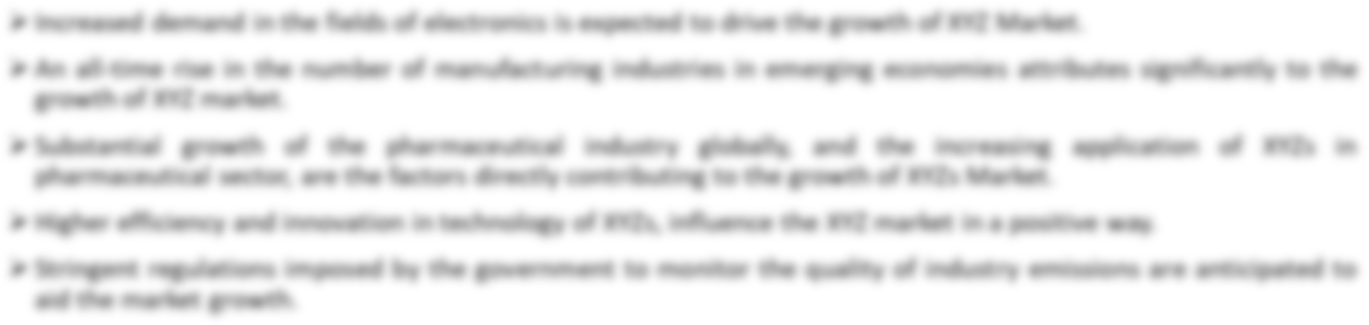
M a r k e t R e s e a r c h . B i z
  - Taxonomy

    - By Product Type & End-Use

Product Type | End-Use
Silicone-based | Aerospace & Defense
Acrylic-based | Automotive
 | Electronics
 | Industrial
 | Other End-Uses

    - By Region

North America | Europe | Asia-Pacific | South America | MEA
USA | Germany | China | Brazil | GCC
Canada | UK | Japan | Argentina | South Africa
Mexico | France | South Korea | Rest of South America | Israel
 | Italy | India |  | Rest of MEA
 | Russia | Rest of Asia-Pacific
 | Spain
 | Rest of Europe

  - Drivers for Polyimide Tape (Kapton Tape) Market

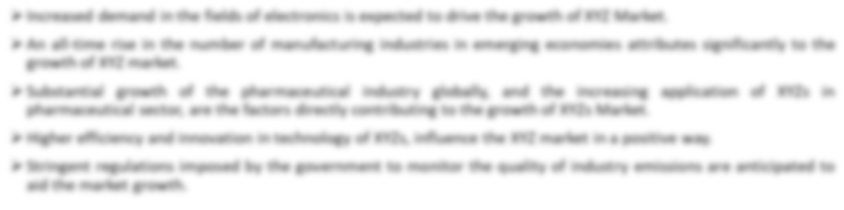
M a r k e t R e s e a r c h . B i z
  - Restraints for Polyimide Tape (Kapton Tape) Market

  - Opportunities for Polyimide Tape (Kapton Tape) Market

  - Trends for Polyimide Tape (Kapton Tape) Market

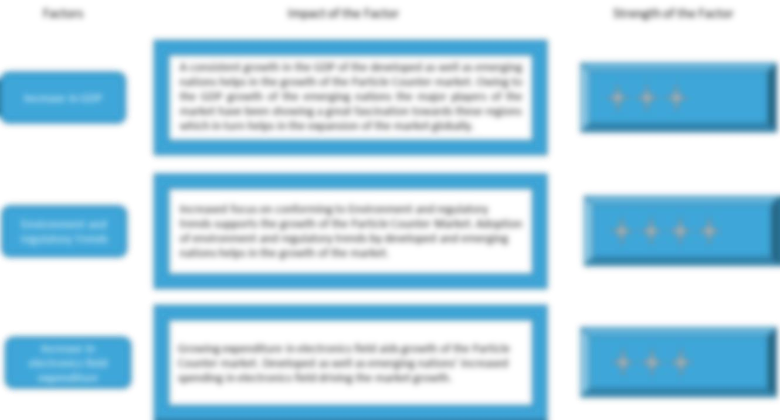
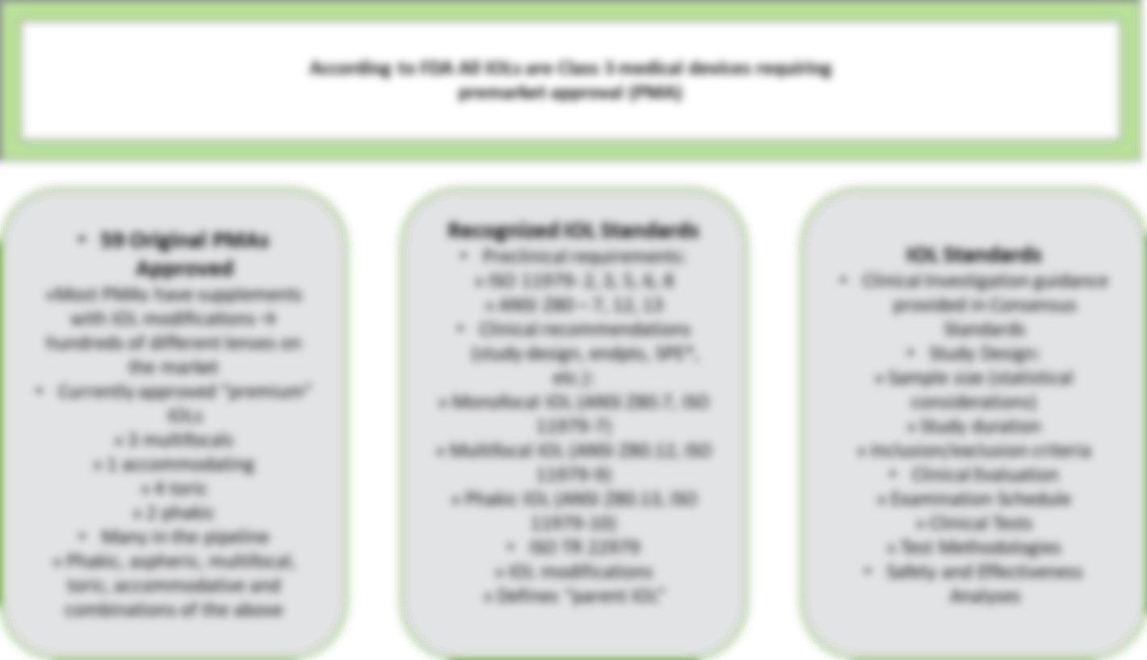
M a r k e t R e s e a r c h . B i z
  - Macro-economic Factors

Source: Prudour, 2020

Regulatory Framework

Source: Prudour, 2020

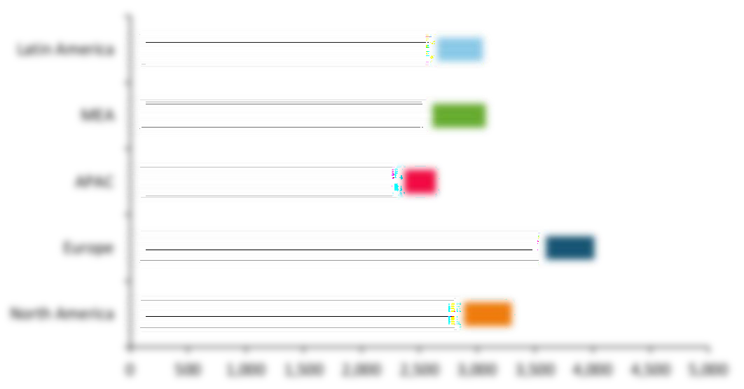
M a r k e t R e s e a r c h . B i z

Global Polyimide Tape (Kapton Tape) Market Pricing Analysis by Region, 2020

Source: Prudour, 2020

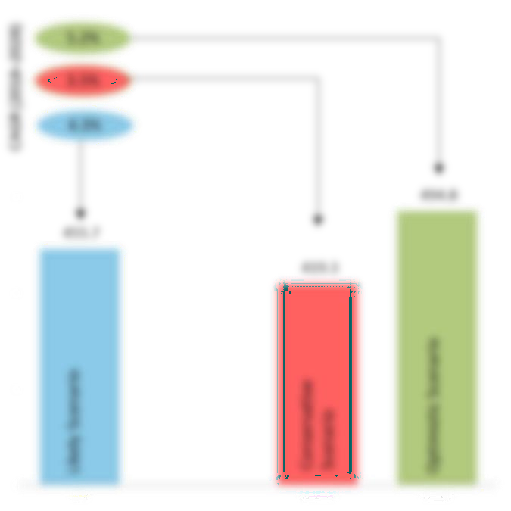
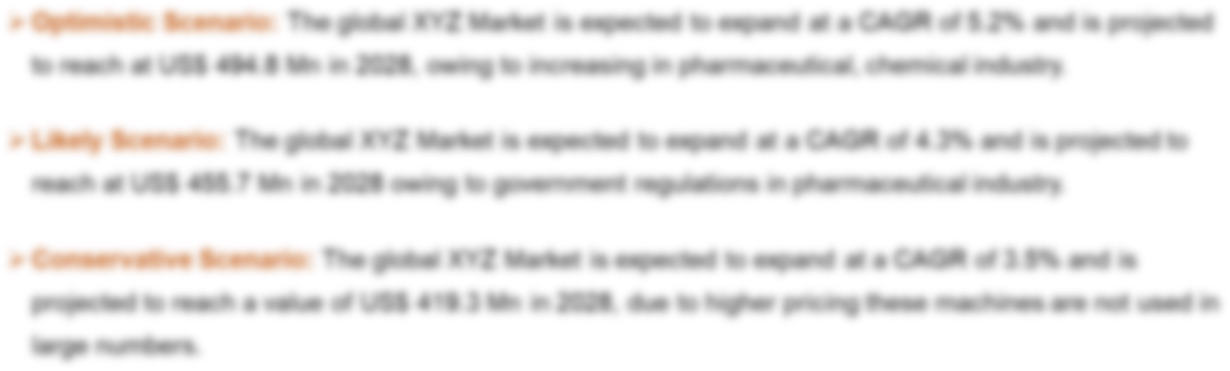
M a r k e t R e s e a r c h . B i z

Opportunity Map Analysis

Source: Prudour, 2020

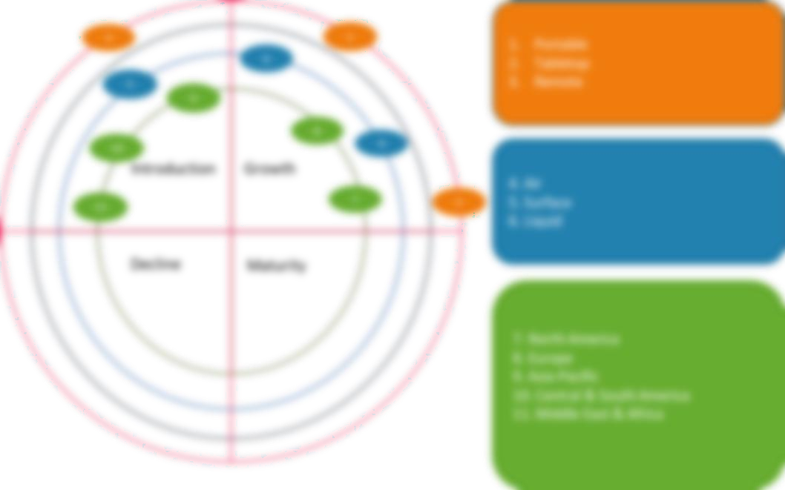
M a r k e t R e s e a r c h . B i z

Opportunity Orbits

Source: Prudour, 2020

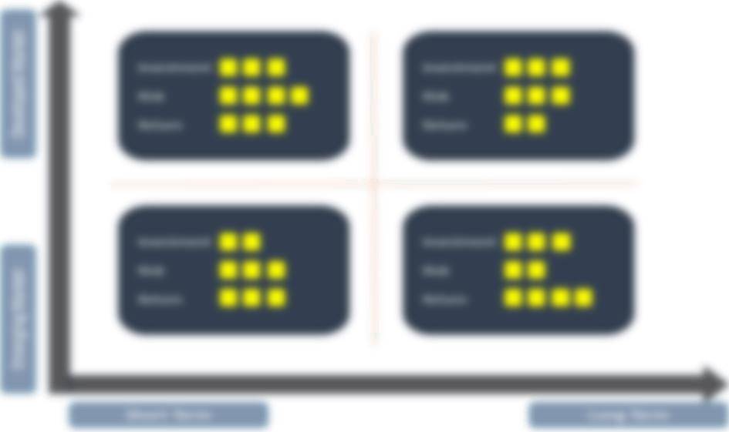

M a r k e t R e s e a r c h . B i z

Market Investment Feasibility Index

Source: Prudour, 2020



M a r k e t R e s e a r c h . B i z

PEST Analysis

Source: Prudour, 2020

PORTER’S Five Force Analysis

Source: Prudour, 2020

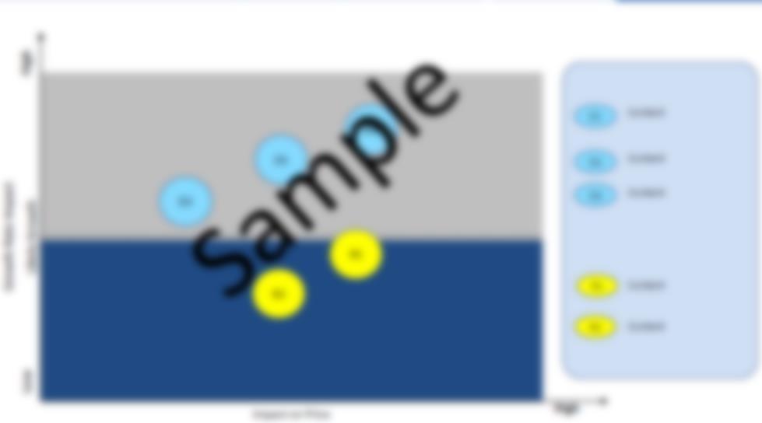
M a r k e t R e s e a r c h . B i z

Drivers & Restraints Impact Analysis

Source: Prudour, 2020

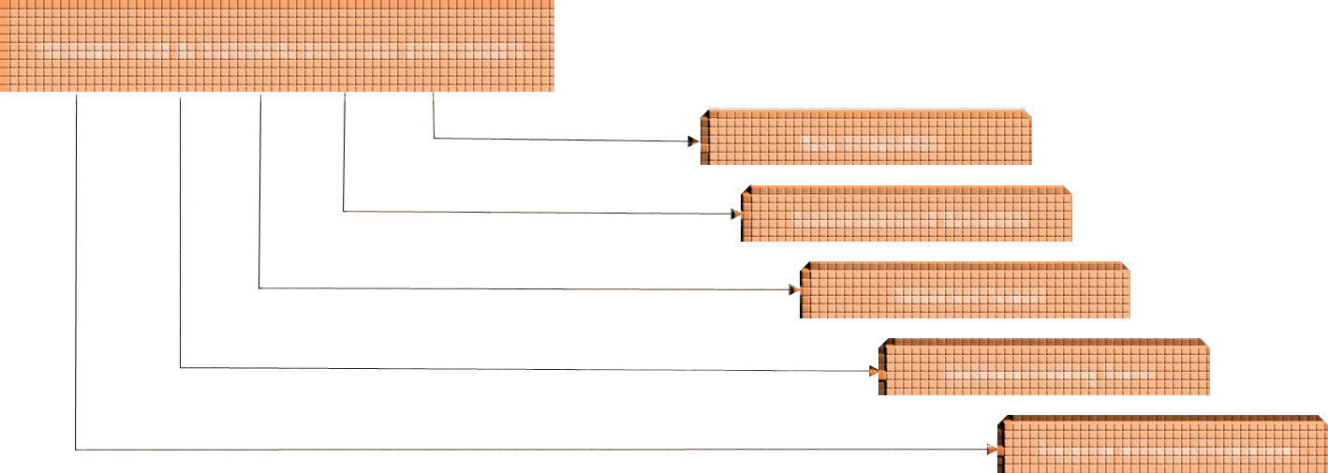
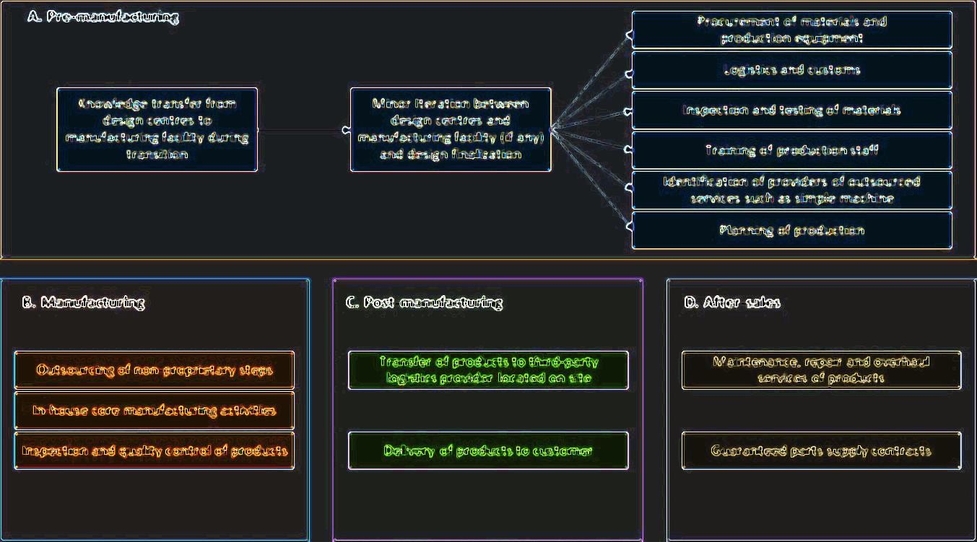
M a r k e t R e s e a r c h . B i z

Marketing Strategy


M a r k e t R e s e a r c h . B i z
  - List of Buyers in USA, Mexico, and Latin America

Source: Prudour, 2020

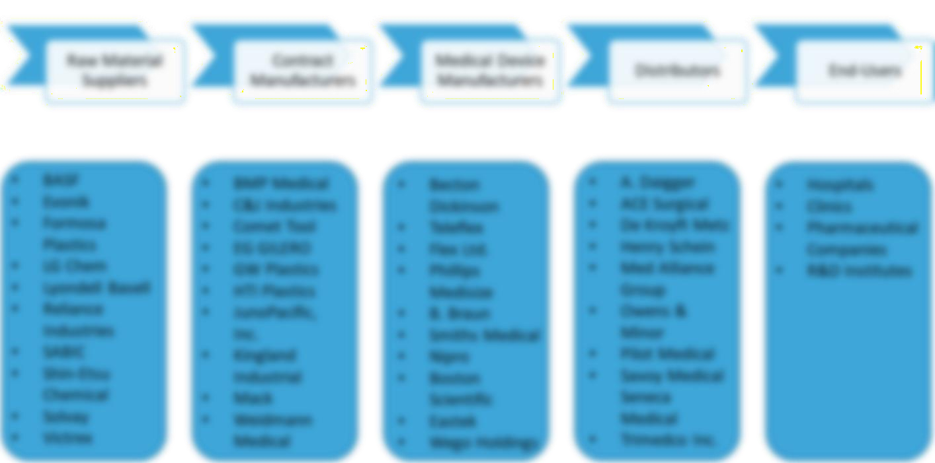

M a r k e t R e s e a r c h . B i z

Industry Chain Analysis

Source: Prudour, 2020

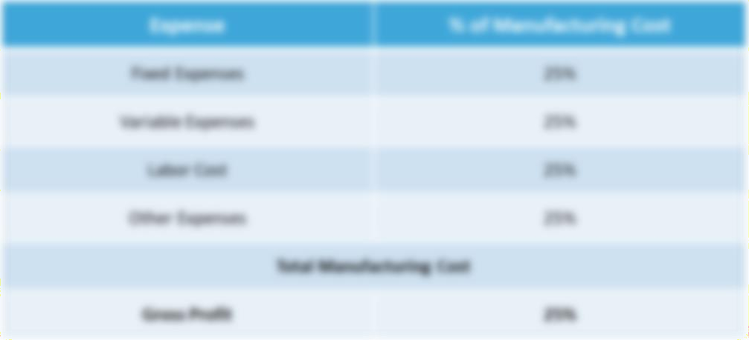
M a r k e t R e s e a r c h . B i z

Cost Structure Analysis

Source: Prudour, 2020

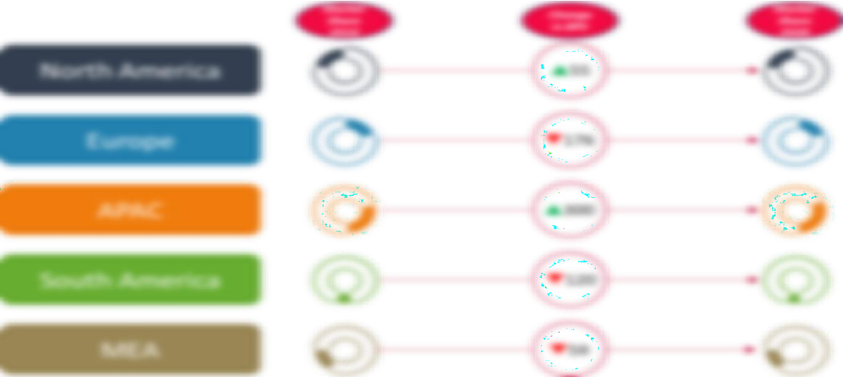
M a r k e t R e s e a r c h . B i z

Regional Market Share and BPS Analysis in Polyimide Tape (Kapton Tape) Market

Source: Prudour, 2020

Note: All the figures are for illustrative purpose only.

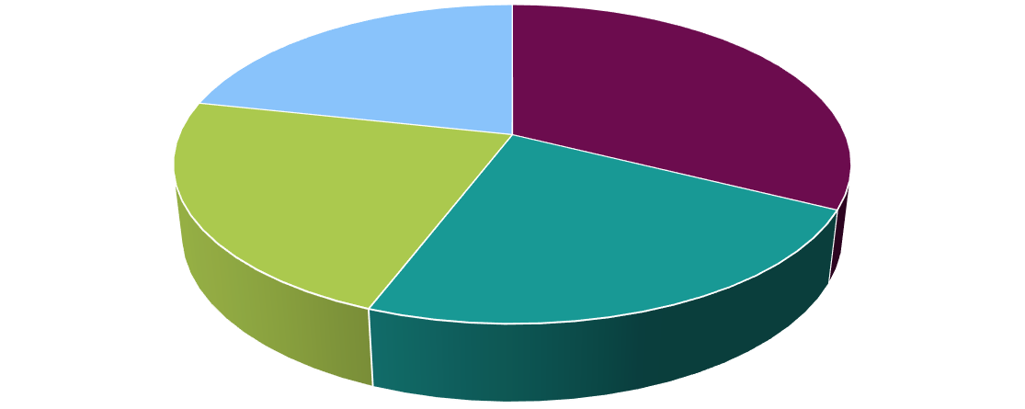
M a r k e t R e s e a r c h . B i z

Chapter 2 Global Polyimide Tape (Kapton Tape) Market Overview

Global Polyimide Tape (Kapton Tape) Market Value & Volume Comparison by Product Type (2014-2030)
TABLE 1 Global Polyimide Tape (Kapton Tape) Market Comparison by Product Type (2014- 2030)

Product Type | 2014 | 2020 | 2030 | F-CAGR
Silicone-based | XX.X | XX.X | XX.X | X.X%
Acrylic-based | XX.X | XX.X | XX.X | X.X%

Source: Prudour, 2020

Global Polyimide Tape (Kapton Tape) Market Value & Volume Market Share by Product Type in 2020
FIG. 1 Global Polyimide Tape (Kapton Tape) Market Value & Volume Market Share by Product Type in 2020

Source: Prudour, 2020





5.0
4.5
4.0
3.5
3.0
2.5
2.0
1.5
1.0
0.5
0.0
0.0
0.5
1.0
1.5
2.0
2.5
3.0
3.5
4.0
4.5
M a r k e t R e s e a r c h . B i z

Global Polyimide Tape (Kapton Tape) Market Attractiveness Analysis by Product Type, 2014–2021
Market Share Index (2020)
FIG. 2 Global Polyimide Tape (Kapton Tape) Market Attractiveness Analysis by Product Type, 2014–2021

Bubble Size represent the Market Value Index, 2030
CAGR Index (2020-2030)
Source: Prudour, 2020

Silicone-based segment is estimated to be the most lucrative segment in Global Polyimide Tape (Kapton Tape) Market with an attractiveness index of XX.X and is expected to grow by a CAGR of XX.X%.

In 2020, the Acrylic-based segment is valued XX.X and the market share was XX.X%, and it is expected to be XX.X and XX.X% in 2029, with a CAGR XX.X% from 2021 to 2030.

Silicone-based segment is estimated to contribute XX.X% in 2020 and is expected to grow at a CAGR of XX.X% during the forecast period.

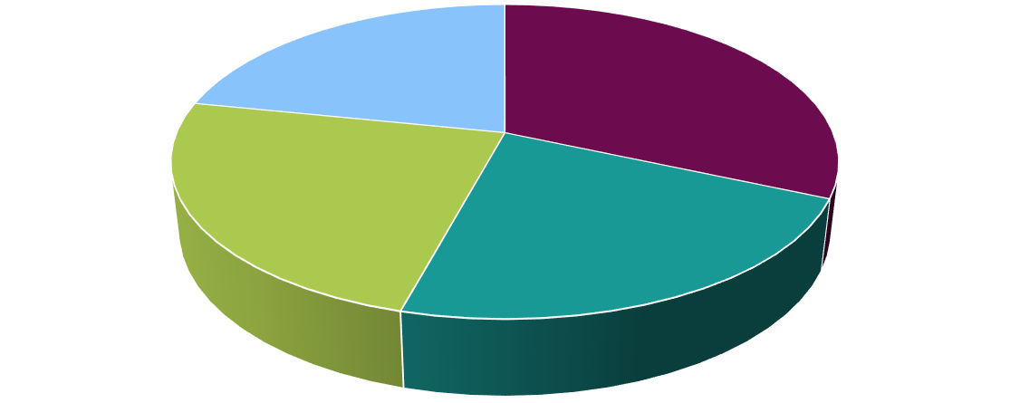
M a r k e t R e s e a r c h . B i z
  - Global Polyimide Tape (Kapton Tape) Market by End-Use

    - Global Polyimide Tape (Kapton Tape) Market Value & Volume Comparison by End-Use (2014-2030)

TABLE 2 Global Polyimide Tape (Kapton Tape) Market Comparison by End-Use (2014-2030)

End-Use | 2014 | 2020 | 2030 | F-CAGR
Aerospace & Defense | XX.X | XX.X | XX.X | X.X%
Automotive | XX.X | XX.X | XX.X | X.X%
Electronics | XX.X | XX.X | XX.X | X.X%
Industrial | XX.X | XX.X | XX.X | X.X%
Other End-Uses | XX.X | XX.X | XX.X | X.X%
Source: Prudour, 2020

Global Polyimide Tape (Kapton Tape) Market Value & Volume Market Share by End-Use in 2020
FIG. 3 Global Polyimide Tape (Kapton Tape) Market Value & Volume Market Share by End- Use in 2020

Source: Prudour, 2020




4.5
4.0
3.5
3.0
2.5
2.0
1.5
1.0
0.5
0.0
0.0
1.0
2.0
3.0
4.0
5.0
6.0
M a r k e t R e s e a r c h . B i z

Global Polyimide Tape (Kapton Tape) Market Attractiveness Analysis by End-Use, 2014–2021
FIG. 4 Global Polyimide Tape (Kapton Tape) Market Attractiveness Analysis by End-Use, 2014–2021

Bubble Size represent the Market Value Index, 2030
CAGR Index (2020-2030)

Source: Prudour, 2020
Market Share Index (2020)

Aerospace & Defense segment is estimated to be the most lucrative segment in Global Polyimide Tape (Kapton Tape) Market with an attractiveness index of 6. and is expected to grow by a CAGR of XX.X%.

Aerospace & Defense segment is estimated to contribute XX.X% in 2020 and is expected to grow at a CAGR of XX.X% during the forecast period.

In 2020, the Automotive segment is valued XX.X and the market share was XX.X%, and it is expected to be XX.X and XX.X% in 2029, with a CAGR XX.X% from 2021 to 2030.

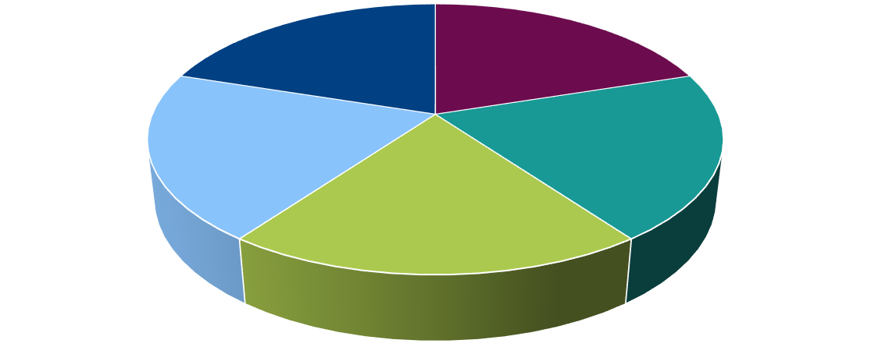
M a r k e t R e s e a r c h . B i z
  - Global Polyimide Tape (Kapton Tape) Market Outlook by Region

    - Global Polyimide Tape (Kapton Tape) Market Value & Volume Comparison by Region (2014-2030)
TABLE 3 Global Polyimide Tape (Kapton Tape) Market Value & Volume Comparison by Region (2014-2030)

Region | 2014 | 2020 | 2030 | F-CAGR
North America | XX.X | XX.X | XX.X | X.X%
Europe | XX.X | XX.X | XX.X | X.X%
APAC | XX.X | XX.X | XX.X | X.X%
South America | XX.X | XX.X | XX.X | X.X%
MEA | XX.X | XX.X | XX.X | X.X%

Source: Prudour, 2020

Global Polyimide Tape (Kapton Tape) Market Value & Volume Market Share by Region in 2020
FIG. 5 Global Polyimide Tape (Kapton Tape) Market Value & Volume Market Share by Region in 2020

North America Europe APAC South America MEA

Source: Prudour, 2020






3.5

3.0

2.5

2.0

1.5

1.0

0.5

0.0
0.0
0.5
1.0
1.5
2.0
2.5
3.0
3.5
M a r k e t R e s e a r c h . B i z

Global Polyimide Tape (Kapton Tape) Market Attractiveness Analysis by Region, 2014– 2021
FIG. 6 Global Polyimide Tape (Kapton Tape) Market Attractiveness Analysis by Region, 2014–2021

Bubble Size represent the Market Value Index, 2030
CAGR Index (2020-2030)

Source: Prudour, 2020
Market Share Index (2020)

North America is estimated to be the most lucrative market in Global Polyimide Tape (Kapton Tape) Market with an attractiveness index of XX.X and is expected to grow by a CAGR of XX.X%.

North America market is estimated to contribute XX.X% in 2020 and is expected to grow at a CAGR of XX.X% during the forecast period.

In 2020, the Europe market is valued XX.X and the market share was XX.X%, and it is expected to be
XX.X and XX.X% in 2029, with a CAGR XX.X% from 2021 to 2030.

350 ,000.0
3.7 %

3.6 %
300 ,000.0
3.5 %
250 ,000.0
3.4 %
200 ,000.0
3.3 %

3.2 %
150 ,000.0
3.1 %
100 ,000.0
3.0 %
50, 000.0
2.9 %
0.0
2.8 %
2013
2014
2015
2016
2017
2018
2019
2020
Global
Y-o-Y Growth Rate
M a r k e t R e s e a r c h . B i z
  - Global Polyimide Tape (Kapton Tape) Market Outlook (2014-2030)

    - Global Polyimide Tape (Kapton Tape) Market Value & Volume (2014–2021)

TABLE 4 Global Polyimide Tape (Kapton Tape) Market Value & Volume (2014–2021)

Year | 2014 | 2015 | 2016 | 2017 | 2018 | 2019 | 2020 | 2021
Global | XX.X | XX.X | XX.X | XX.X | XX.X | XX.X | XX.X | XX.X
Y-o-Y Growth Rate |  | X.X% | X.X% | X.X% | X.X% | X.X% | X.X% | X.X%
Source: Prudour, 2020

FIG. 7 Global Polyimide Tape (Kapton Tape) Market Value & Volume (2014–2021)

Source: Prudour, 2020

450 ,000.0
4.3 %
400 ,000.0
4.2 %
350 ,000.0
4.1 %
300 ,000.0
4.0 %
250 ,000.0
3.9 %
200 ,000.0
3.8 %
150 ,000.0
3.7 %
100 ,000.0
3.6 %
50, 000.0
3.5 %
0.0
3.4 %
2021
2022
2023
2024
2025
2026
2027
2028
2029
Global
Y-o-Y Growth Rate
M a r k e t R e s e a r c h . B i z

Global Polyimide Tape (Kapton Tape) Market Value & Volume (2022-2030)

TABLE 5 Global Polyimide Tape (Kapton Tape) Market Value & Volume (2022-2030)

Year | 2022 | 2023 | 2024 | 2025 | 2026 | 2027 | 2028 | 2029 | 2030
Global | XX.X | XX.X | XX.X | XX.X | XX.X | XX.X | XX.X | XX.X | XX.X
Y-o-Y Growth Rate | X.X% | X.X% | X.X% | X.X% | X.X% | X.X% | X.X% | X.X% | X.X%
Source: Prudour, 2020

FIG. 8 Global Polyimide Tape (Kapton Tape) Market Value & Volume (2022-2030)

Source: Prudour, 2020

M a r k e t R e s e a r c h . B i z

Global Polyimide Tape (Kapton Tape) Market Value & Volume by Regions

    - Global Polyimide Tape (Kapton Tape) Market Value & Volume Comparison by Region (2014–2021)
TABLE 6 Global Polyimide Tape (Kapton Tape) Market Value & Volume Comparison by Region (2014–2021)

Year | 2014 | 2015 | 2016 | 2017 | 2018 | 2019 | 2020 | 2021
North America | XX.X | XX.X | XX.X | XX.X | XX.X | XX.X | XX.X | XX.X
Europe | XX.X | XX.X | XX.X | XX.X | XX.X | XX.X | XX.X | XX.X
APAC | XX.X | XX.X | XX.X | XX.X | XX.X | XX.X | XX.X | XX.X
South America | XX.X | XX.X | XX.X | XX.X | XX.X | XX.X | XX.X | XX.X
MEA | XX.X | XX.X | XX.X | XX.X | XX.X | XX.X | XX.X | XX.X

Source: Prudour, 2020
FIG. 9 Global Polyimide Tape (Kapton Tape) Market Value & Volume Comparison by Region (2014–2021)

2013 2014 2015 2016 2017 2018 2019 2020

Source: Prudour, 2020

Global Polyimide Tape (Kapton Tape) Market Value & Volume Comparison by Region (2022-2030)
TABLE 7 Global Polyimide Tape (Kapton Tape) Market Value & Volume Comparison by Region (2022-2030)

Year | 2022 | 2023 | 2024 | 2025 | 2026 | 2027 | 2028 | 2029 | 2030
North America | XX.X | XX.X | XX.X | XX.X | XX.X | XX.X | XX.X | XX.X | XX.X
Europe | XX.X | XX.X | XX.X | XX.X | XX.X | XX.X | XX.X | XX.X | XX.X
APAC | XX.X | XX.X | XX.X | XX.X | XX.X | XX.X | XX.X | XX.X | XX.X
South America | XX.X | XX.X | XX.X | XX.X | XX.X | XX.X | XX.X | XX.X | XX.X
MEA | XX.X | XX.X | XX.X | XX.X | XX.X | XX.X | XX.X | XX.X | XX.X

Source: Prudour, 2020

M a r k e t R e s e a r c h . B i z
FIG. 10 Global Polyimide Tape (Kapton Tape) Market Value & Volume Comparison by Region (2022-2030)

2021 2022 2023 2024 2025 2026 2027 2028 2029
Source: Prudour, 2020

The Polyimide Tape (Kapton Tape) Market in North America is estimated to account for a Value & Volume share of XX.X% in 2020, and is expected to register a CAGR of XX.X% during the forecast period

In 2020, the market in Europe is estimated to be valued US$ XX.X and register a market share of XX.X%. The market is expected to reach a value of US$ XX.X and register a CAGR of XX.X% between 2021 and 2030.

The first five-year cumulative Value & Volume in Asia-Pacific market (2021-2025) is estimated to be US$ XX.X Mn, as compared to a moderately higher cumulative Value & Volume of US$ XX.X Mn for the latter five years of the forecast period (2026–2030)

M a r k e t R e s e a r c h . B i z
  - Global Polyimide Tape (Kapton Tape) Market Value & Volume by Product Type

    - Global Polyimide Tape (Kapton Tape) Market Value & Volume Comparison by Product Type (2014–2021)
TABLE 8 Global Polyimide Tape (Kapton Tape) Market Value & Volume Comparison by Product Type (2014–2021)

Year | 2014 | 2015 | 2016 | 2017 | 2018 | 2019 | 2020 | 2021
Silicone-based | XX.X | XX.X | XX.X | XX.X | XX.X | XX.X | XX.X | XX.X
Acrylic-based | XX.X | XX.X | XX.X | XX.X | XX.X | XX.X | XX.X | XX.X

Source: Prudour, 2020
FIG. 11 Global Polyimide Tape (Kapton Tape) Market Value & Volume Comparison by Product Type (2014–2021)

2013 2014 2015 2016 2017 2018 2019 2020

Source: Prudour, 2020

M a r k e t R e s e a r c h . B i z

Global Polyimide Tape (Kapton Tape) Market Value & Volume Comparison by Product Type (2022-2030)
TABLE 9 Global Polyimide Tape (Kapton Tape) Market Value & Volume Comparison by Product Type (2022-2030)

Year | 2022 | 2023 | 2024 | 2025 | 2026 | 2027 | 2028 | 2029 | 2030
Silicone-based | XX.X | XX.X | XX.X | XX.X | XX.X | XX.X | XX.X | XX.X | XX.X
Acrylic-based | XX.X | XX.X | XX.X | XX.X | XX.X | XX.X | XX.X | XX.X | XX.X

Source: Prudour, 2020
FIG. 12 Global Polyimide Tape (Kapton Tape) Market Value & Volume Comparison by Product Type (2022-2030)

2021 2022 2023 2024 2025 2026 2027 2028 2029

Source: Prudour, 2020

Silicone-based segment was valued at US$ XX.X Mn in 2019 and is projected to reach US$ XX.X Mn in 2030, and register a CAGR of XX.X% during the forecast period.

Value & Volume from the Acrylic-based segment in the global Polyimide Tape (Kapton Tape) Market is projected to register a CAGR of XX.X% during the forecast period

The first five-year cumulative Value & Volume (2021-2025) is estimated to be US$ XX.X Mn, as compared to a moderately higher cumulative Value & Volume of US$ XX.X Mn for the latter five years of the forecast period (2026–2030)

M a r k e t R e s e a r c h . B i z
  - Global Polyimide Tape (Kapton Tape) Market Value & Volume by End-Use

    - Global Polyimide Tape (Kapton Tape) Market Value & Volume Comparison by End-Use (2014–2021)
TABLE 10 Global Polyimide Tape (Kapton Tape) Market Value & Volume Comparison by End- Use (2014–2021)

Year | 2014 | 2015 | 2016 | 2017 | 2018 | 2019 | 2020 | 2021
Aerospace & Defense | XX.X | XX.X | XX.X | XX.X | XX.X | XX.X | XX.X | XX.X
Automotive | XX.X | XX.X | XX.X | XX.X | XX.X | XX.X | XX.X | XX.X
Electronics | XX.X | XX.X | XX.X | XX.X | XX.X | XX.X | XX.X | XX.X
Industrial | XX.X | XX.X | XX.X | XX.X | XX.X | XX.X | XX.X | XX.X
Other End-Uses | XX.X | XX.X | XX.X | XX.X | XX.X | XX.X | XX.X | XX.X

Source: Prudour, 2020
FIG. 13 Global Polyimide Tape (Kapton Tape) Market Value & Volume Comparison by End-Use (2014–2021)

2013 2014 2015 2016 2017 2018 2019 2020

Source: Prudour, 2020

M a r k e t R e s e a r c h . B i z

Global Polyimide Tape (Kapton Tape) Market Value & Volume Comparison by End-Use (2022-2030)
TABLE 11 Global Polyimide Tape (Kapton Tape) Market Value & Volume Comparison by End- Use (2022-2030)

Year | 2022 | 2023 | 2024 | 2025 | 2026 | 2027 | 2028 | 2029 | 2030
Aerospace & Defense | XX.X | XX.X | XX.X | XX.X | XX.X | XX.X | XX.X | XX.X | XX.X
Automotive | XX.X | XX.X | XX.X | XX.X | XX.X | XX.X | XX.X | XX.X | XX.X
Electronics | XX.X | XX.X | XX.X | XX.X | XX.X | XX.X | XX.X | XX.X | XX.X
Industrial | XX.X | XX.X | XX.X | XX.X | XX.X | XX.X | XX.X | XX.X | XX.X
Other End-Uses | XX.X | XX.X | XX.X | XX.X | XX.X | XX.X | XX.X | XX.X | XX.X

Source: Prudour, 2020
FIG. 14 Global Polyimide Tape (Kapton Tape) Market Value & Volume Comparison by End- Use (2022-2030)

2021 2022 2023 2024 2025 2026 2027 2028 2029

Source: Prudour, 2020

Aerospace & Defense segment was valued at US$ XX.X Mn in 2019 and is projected to reach US$
XX.X Mn in 2029, and register a CAGR of XX.X% during the forecast period.

Value & Volume from the Automotive segment in the global Polyimide Tape (Kapton Tape) Market is projected to register a CAGR of 3% during the forecast period

Electronics segment was valued at US$ XX.X Mn in 2019 and is projected to reach US$ XX Mn in 2029, and register a CAGR of XX.X% during the forecast period.

Value & Volume from the Industrial segment in the global Polyimide Tape (Kapton Tape) Market is projected to register a CAGR of XX.X% during the forecast period

M a r k e t R e s e a r c h . B i z
  - Global Polyimide Tape (Kapton Tape) Market Y-o-Y Growth Rate Comparison 2015–2030

    - Global Polyimide Tape (Kapton Tape) Market Y-o-Y Growth Rate by Region
TABLE 12 Global Polyimide Tape (Kapton Tape) Market Y-o-Y Growth Rate Comparison by Region (2015-2021)

Year | 2015 | 2016 | 2017 | 2018 | 2019 | 2020 | 2021
North America | X.X% | X.X% | X.X% | X.X% | X.X% | X.X% | X.X%
Europe | X.X% | X.X% | X.X% | X.X% | X.X% | X.X% | X.X%
APAC | X.X% | X.X% | X.X% | X.X% | X.X% | X.X% | X.X%
South America | X.X% | X.X% | X.X% | X.X% | X.X% | X.X% | X.X%
MEA | X.X% | X.X% | X.X% | X.X% | X.X% | X.X% | X.X%

Source: Prudour, 2020
FIG. 15 Global Polyimide Tape (Kapton Tape) Market Y-o-Y Growth Rate Comparison by Region (2015-2021)

2014 2015 2016 2017 2018 2019 2020

Source: Prudour, 2020
TABLE 13 Global Polyimide Tape (Kapton Tape) Market Y-o-Y Growth Rate Comparison by Region (2022-2030)

Year | 2022 | 2023 | 2024 | 2025 | 2026 | 2027 | 2028 | 2029 | 2030
North America | X.X% | X.X% | X.X% | X.X% | X.X% | X.X% | X.X% | X.X% | X.X%
Europe | X.X% | X.X% | X.X% | X.X% | X.X% | X.X% | X.X% | X.X% | X.X%
APAC | X.X% | X.X% | X.X% | X.X% | X.X% | X.X% | X.X% | X.X% | X.X%
South America | X.X% | X.X% | X.X% | X.X% | X.X% | X.X% | X.X% | X.X% | X.X%
MEA | X.X% | X.X% | X.X% | X.X% | X.X% | X.X% | X.X% | X.X% | X.X%

Source: Prudour, 2020

M a r k e t R e s e a r c h . B i z
FIG. 16 Global Polyimide Tape (Kapton Tape) Market Y-o-Y Growth Rate Comparison by Region (2022-2030)

2021 2022 2023 2024 2025 2026 2027 2028 2029
Source: Prudour, 2020

North America in the global Polyimide Tape (Kapton Tape) Market is expected to register Y-o-Y growth rate of more than XX.X% during the forecast period

In 2020, the market in Europe is estimated to be valued US$ XX.X and register a market share of XX.X%. The market is expected to reach a value of US$ XX.X and register a CAGR of XX.X% between 2020 and 2029.

The Polyimide Tape (Kapton Tape) Market in Asia-Pacific is estimated to account for a Value & Volume share of XX.X% in 2020, and is expected to register a CAGR of XX.X% during the forecast period

The Polyimide Tape (Kapton Tape) Market in South America was valued at US$ XX.X Mn in 2018 and is projected to reach US$ XX.X Mn in 2029, and register a CAGR of 5 % during the forecast period.

    - Global Polyimide Tape (Kapton Tape) Market Y-o-Y Growth Rate by Product Type
TABLE 14 Global Polyimide Tape (Kapton Tape) Market Y-o-Y Growth Rate Comparison by Product Type (2015-2021)

Year | 2015 | 2016 | 2017 | 2018 | 2019 | 2020 | 2021
Silicone-based | X.X% | X.X% | X.X% | X.X% | X.X% | X.X% | X.X%
Acrylic-based | X.X% | X.X% | X.X% | X.X% | X.X% | X.X% | X.X%

Source: Prudour, 2020

M a r k e t R e s e a r c h . B i z
FIG. 17 Global Polyimide Tape (Kapton Tape) Market Y-o-Y Growth Rate Comparison by Product Type (2015-2021)

2014 2015 2016 2017 2018 2019 2020
Source: Prudour, 2020
TABLE 15 Global Polyimide Tape (Kapton Tape) Market Y-o-Y Growth Rate Comparison by Product Type (2022-2030)

Year | 2022 | 2023 | 2024 | 2025 | 2026 | 2027 | 2028 | 2029 | 2030
Silicone-based | X.X% | X.X% | X.X% | X.X% | X.X% | X.X% | X.X% | X.X% | X.X%
Acrylic-based | X.X% | X.X% | X.X% | X.X% | X.X% | X.X% | X.X% | X.X% | X.X%

Source: Prudour, 2020

M a r k e t R e s e a r c h . B i z
FIG. 18 Global Polyimide Tape (Kapton Tape) Market Y-o-Y Growth Rate Comparison by Product Type (2022-2030)

2021 2022 2023 2024 2025 2026 2027 2028 2029
Source: Prudour, 2020

Silicone-based segment in the global Polyimide Tape (Kapton Tape) Market is expected to register Y- o-Y growth rate of more than X% during the forecast period

Value & Volume from the Acrylic-based segment in the global Polyimide Tape (Kapton Tape) Market is projected to register a CAGR of XX.X% during the forecast period

    - Global Polyimide Tape (Kapton Tape) Market Y-o-Y Growth Rate by End-Use
TABLE 16 Global Polyimide Tape (Kapton Tape) Market Y-o-Y Growth Rate Comparison by End-Use (2015-2021)

Year | 2015 | 2016 | 2017 | 2018 | 2019 | 2020 | 2021
Aerospace & Defense | X.X% | X.X% | X.X% | X.X% | X.X% | X.X% | X.X%
Automotive | X.X% | X.X% | X.X% | X.X% | X.X% | X.X% | X.X%
Electronics | X.X% | X.X% | X.X% | X.X% | X.X% | X.X% | X.X%
Industrial | X.X% | X.X% | X.X% | X.X% | X.X% | X.X% | X.X%
Other End-Uses | X.X% | X.X% | X.X% | X.X% | X.X% | X.X% | X.X%

Source: Prudour, 2020

4.5%
4.3%
4.1%
3.9%
3.7%
3.5%
3.3%
3.1%
2.9%
2.7%
2.5%
2014
2015
2016
2017
2018
2019
2020
M a r k e t R e s e a r c h . B i z
FIG. 19 Global Polyimide Tape (Kapton Tape) Market Y-o-Y Growth Rate Comparison by End- Use (2015-2021)

Source: Prudour, 2020
TABLE 17 Global Polyimide Tape (Kapton Tape) Market Y-o-Y Growth Rate Comparison by End-Use (2022-2030)

Year | 2022 | 2023 | 2024 | 2025 | 2026 | 2027 | 2028 | 2029 | 2030
Aerospace & Defense | X.X% | X.X% | X.X% | X.X% | X.X% | X.X% | X.X% | X.X% | X.X%
Automotive | X.X% | X.X% | X.X% | X.X% | X.X% | X.X% | X.X% | X.X% | X.X%
Electronics | X.X% | X.X% | X.X% | X.X% | X.X% | X.X% | X.X% | X.X% | X.X%
Industrial | X.X% | X.X% | X.X% | X.X% | X.X% | X.X% | X.X% | X.X% | X.X%
Other End-Uses | X.X% | X.X% | X.X% | X.X% | X.X% | X.X% | X.X% | X.X% | X.X%

Source: Prudour, 2020

M a r k e t R e s e a r c h . B i z
FIG. 20 Global Polyimide Tape (Kapton Tape) Market Y-o-Y Growth Rate Comparison by End- Use (2022-2030)

2021 2022 2023 2024 2025 2026 2027 2028 2029
Source: Prudour, 2020

Aerospace & Defense segment in the global Polyimide Tape (Kapton Tape) Market is expected to register Y-o-Y growth rate of more than XX.X% during the forecast period

Value & Volume from the Automotive segment in the global Polyimide Tape (Kapton Tape) Market is projected to register a CAGR of 3% during the forecast period

Electronics segment was valued at US$ XX.X Mn in 2019 and is projected to reach US$ XX Mn in 2029, and register a CAGR of XX.X% during the forecast period.

Industrial segment was valued at US$ XX.X Mn in 2019 and is projected to reach US$ XX.X Mn in 2030, and register a CAGR of XX.X% during the forecast period.

M a r k e t R e s e a r c h . B i z
  - Global Polyimide Tape (Kapton Tape) Market Share Comparison 2014–2030

    - Global Polyimide Tape (Kapton Tape) Market Share by Region
TABLE 18 Global Polyimide Tape (Kapton Tape) Market Share Comparison by Region (2014– 2021)

Year | 2014 | 2015 | 2016 | 2017 | 2018 | 2019 | 2020 | 2021
North America | XX.X% | XX.X% | XX.X% | XX.X% | XX.X% | XX.X% | XX.X% | XX.X%
Europe | XX.X% | XX.X% | XX.X% | XX.X% | XX.X% | XX.X% | XX.X% | XX.X%
APAC | XX.X% | XX.X% | XX.X% | XX.X% | XX.X% | XX.X% | XX.X% | XX.X%
South America | XX.X% | XX.X% | XX.X% | XX.X% | XX.X% | XX.X% | XX.X% | XX.X%
MEA | XX.X% | XX.X% | XX.X% | XX.X% | XX.X% | XX.X% | XX.X% | XX.X%

Source: Prudour, 2020
FIG. 21 Global Polyimide Tape (Kapton Tape) Market Share Comparison by Region (2014– 2021)

2013 2020

Source: Prudour, 2020
TABLE 19 Global Polyimide Tape (Kapton Tape) Market Share Comparison by Region (2022- 2030)

Year | 2022 | 2023 | 2024 | 2025 | 2026 | 2027 | 2028 | 2029 | 2030
North America | XX.X% | XX.X% | XX.X% | XX.X% | XX.X% | XX.X% | XX.X% | XX.X% | XX.X%
Europe | XX.X% | XX.X% | XX.X% | XX.X% | XX.X% | XX.X% | XX.X% | XX.X% | XX.X%
APAC | XX.X% | XX.X% | XX.X% | XX.X% | XX.X% | XX.X% | XX.X% | XX.X% | XX.X%
South America | XX.X% | XX.X% | XX.X% | XX.X% | XX.X% | XX.X% | XX.X% | XX.X% | XX.X%
MEA | XX.X% | XX.X% | XX.X% | XX.X% | XX.X% | XX.X% | XX.X% | XX.X% | XX.X%

Source: Prudour, 2020

M a r k e t R e s e a r c h . B i z
FIG. 22 Global Polyimide Tape (Kapton Tape) Market Share Comparison by Region (2022- 2030)

2021 2029
Source: Prudour, 2020

North America market is estimated to contribute XX.X% share in global Polyimide Tape (Kapton Tape) Market in 2020 and is expected to lose 146 BPS point by end of 2029

The Polyimide Tape (Kapton Tape) Market in Europe is estimated to account for a Value & Volume share of XX.X% in 2020, and is expected to register a CAGR of XX.X% during the forecast period

Asia-Pacific market is estimated to contribute XX.X% share in global Polyimide Tape (Kapton Tape) Market in 2020 and is expected to lose 182 BPS point by end of 2029

In 2020, the market in South America is estimated to be valued US$ XX.X and register a market share of XX.X%. The market is expected to reach a value of US$ XX.X and register a CAGR of X% between 2020 and 2029.

M a r k e t R e s e a r c h . B i z
    - Global Polyimide Tape (Kapton Tape) Market Share by Product Type
TABLE 20 Global Polyimide Tape (Kapton Tape) Market Share Comparison by Product Type (2014–2021)

Year | 2014 | 2015 | 2016 | 2017 | 2018 | 2019 | 2020 | 2021
Silicone-based | XX.X% | XX.X% | XX.X% | XX.X% | XX.X% | XX.X% | XX.X% | XX.X%
Acrylic-based | XX.X% | XX.X% | XX.X% | XX.X% | XX.X% | XX.X% | XX.X% | XX.X%

Source: Prudour, 2020
FIG. 23 Global Polyimide Tape (Kapton Tape) Market Share Comparison by Product Type (2014–2021)

2013 2020

Source: Prudour, 2019
TABLE 21 Global Polyimide Tape (Kapton Tape) Market Share Comparison by Product Type (2022-2030)

Year | 2022 | 2023 | 2024 | 2025 | 2026 | 2027 | 2028 | 2029 | 2030
Silicone-based | XX.X% | XX.X% | XX.X% | XX.X% | XX.X% | XX.X% | XX.X% | XX.X% | XX.X%
Acrylic-based | XX.X% | XX.X% | XX.X% | XX.X% | XX.X% | XX.X% | XX.X% | XX.X% | XX.X%

Source: Prudour, 2020

M a r k e t R e s e a r c h . B i z
FIG. 24 Global Polyimide Tape (Kapton Tape) Market Share Comparison by Product Type (2022-2030)

2021 2029
Source: Prudour, 2020

Silicone-based segment is estimated to contribute XX.X% share in global Polyimide Tape (Kapton Tape) Market in 2020 and is expected to gain 18 BPS point by end of 2029

Acrylic-based segment in the global Polyimide Tape (Kapton Tape) Market is expected to register Y-o- Y growth rate of more than XX.X% during the forecast period

M a r k e t R e s e a r c h . B i z
    - Global Polyimide Tape (Kapton Tape) Market Share by End-Use
TABLE 22 Global Polyimide Tape (Kapton Tape) Market Share Comparison by End-Use (2014– 2021)

Year | 2014 | 2015 | 2016 | 2017 | 2018 | 2019 | 2020 | 2021
Aerospace & Defense | XX.X% | XX.X% | XX.X% | XX.X% | XX.X% | XX.X% | XX.X% | XX.X%
Automotive | XX.X% | XX.X% | XX.X% | XX.X% | XX.X% | XX.X% | XX.X% | XX.X%
Electronics | XX.X% | XX.X% | XX.X% | XX.X% | XX.X% | XX.X% | XX.X% | XX.X%
Industrial | XX.X% | XX.X% | XX.X% | XX.X% | XX.X% | XX.X% | XX.X% | XX.X%
Other End-Uses | XX.X% | XX.X% | XX.X% | XX.X% | XX.X% | XX.X% | XX.X% | XX.X%

Source: Prudour, 2020
FIG. 25 Global Polyimide Tape (Kapton Tape) Market Share Comparison by End-Use (2014– 2021)

2013 2020

Source: Prudour, 2020
TABLE 23 Global Polyimide Tape (Kapton Tape) Market Share Comparison by End-Use (2022- 2030)

Year | 2022 | 2023 | 2024 | 2025 | 2026 | 2027 | 2028 | 2029 | 2030
Aerospace & Defense | XX.X% | XX.X% | XX.X% | XX.X% | XX.X% | XX.X% | XX.X% | XX.X% | XX.X%
Automotive | XX.X% | XX.X% | XX.X% | XX.X% | XX.X% | XX.X% | XX.X% | XX.X% | XX.X%
Electronics | XX.X% | XX.X% | XX.X% | XX.X% | XX.X% | XX.X% | XX.X% | XX.X% | XX.X%
Industrial | XX.X% | XX.X% | XX.X% | XX.X% | XX.X% | XX.X% | XX.X% | XX.X% | XX.X%
Other End-Uses | XX.X% | XX.X% | XX.X% | XX.X% | XX.X% | XX.X% | XX.X% | XX.X% | XX.X%

Source: Prudour, 2020

M a r k e t R e s e a r c h . B i z
FIG. 26 Global Polyimide Tape (Kapton Tape) Market Share Comparison by End-Use (2022- 2030)

2021 2029
Source: Prudour, 2020

Aerospace & Defense segment is estimated to contribute XX.X% share in global Polyimide Tape (Kapton Tape) Market in 2020 and is expected to lose 784 BPS point by end of 2029

Automotive segment in the global Polyimide Tape (Kapton Tape) Market is expected to register Y-o-Y growth rate of more than XX.X% during the forecast period

Electronics segment is estimated to contribute XX.X% share in global Polyimide Tape (Kapton Tape) Market in 2020 and is expected to gain 169 BPS point by end of 2029

Industrial segment was valued at US$ XX.X Mn in 2018 and is projected to reach US$ XX.X Mn in 2029, and register a CAGR of XX.X% during the forecast period.

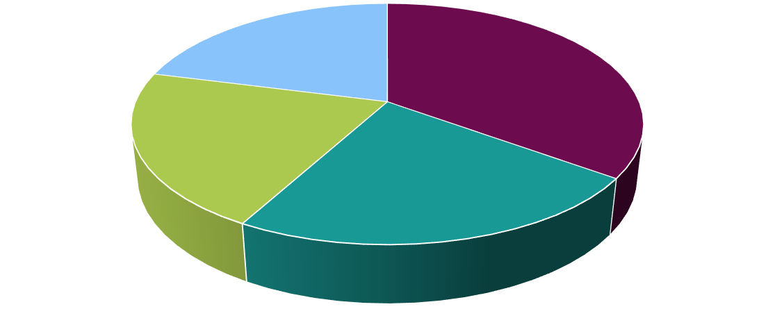
M a r k e t R e s e a r c h . B i z
Chapter 3 North America Polyimide Tape (Kapton Tape) Market Overview

  - North America Polyimide Tape (Kapton Tape) Market by Product Type

    - North America Polyimide Tape (Kapton Tape) Market Value & Volume Comparison by Product Type (2014-2030)
TABLE 24 North America Polyimide Tape (Kapton Tape) Market Comparison by Product Type (2014-2030)

Product Type | 2014 | 2020 | 2030 | F-CAGR
Silicone-based | XX.X | XX.X | XX.X | X.X%
Acrylic-based | XX.X | XX.X | XX.X | X.X%

Source: Prudour, 2020

North America Polyimide Tape (Kapton Tape) Market Value & Volume Market Share by Product Type in 2020
FIG. 27 North America Polyimide Tape (Kapton Tape) Market Value & Volume Market Share by Product Type in 2020

Source: Prudour, 2020

………. cont’d.

Content has been removed from the sample.

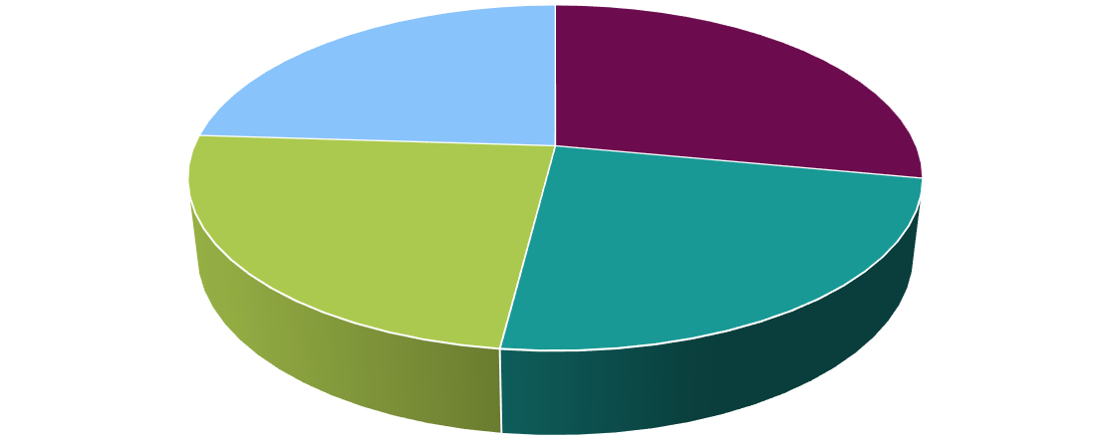
M a r k e t R e s e a r c h . B i z

Chapter 4 Europe Polyimide Tape (Kapton Tape) Market Overview

Europe Polyimide Tape (Kapton Tape) Market by Product Type

    - Europe Polyimide Tape (Kapton Tape) Market Value & Volume Comparison by Product Type (2014-2030)
TABLE 25 Europe Polyimide Tape (Kapton Tape) Market Comparison by Product Type (2014- 2030)

Product Type | 2014 | 2020 | 2030 | F-CAGR
Silicone-based | XX.X | XX.X | XX.X | X.X%
Acrylic-based | XX.X | XX.X | XX.X | X.X%

Source: Prudour, 2020

Europe Polyimide Tape (Kapton Tape) Market Value & Volume Market Share by Product Type in 2020
FIG. 28 Europe Polyimide Tape (Kapton Tape) Market Value & Volume Market Share by Product Type in 2020

Source: Prudour, 2020

………. cont’d.

Content has been removed from the sample.

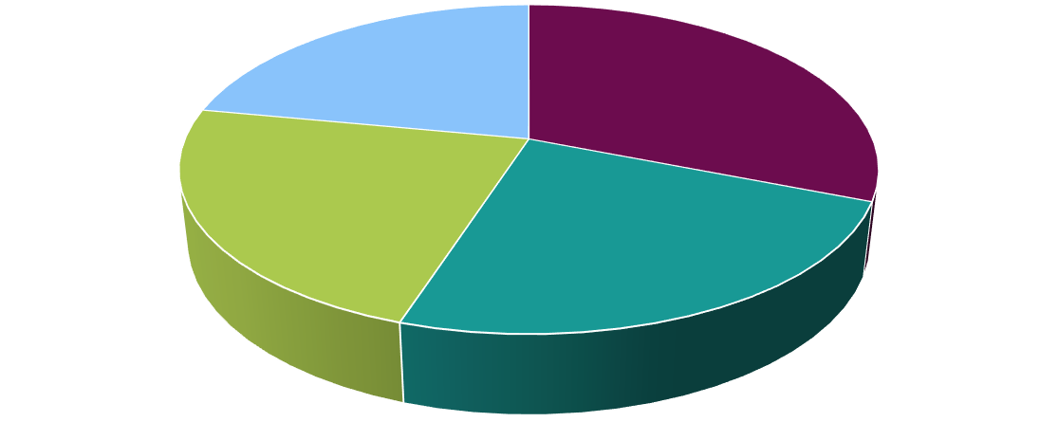
M a r k e t R e s e a r c h . B i z

Chapter 5 Asia-Pacific Polyimide Tape (Kapton Tape) Market Overview

Asia-Pacific Polyimide Tape (Kapton Tape) Market by Product Type

    - Asia-Pacific Polyimide Tape (Kapton Tape) Market Value & Volume Comparison by Product Type (2014-2030)
TABLE 26 Asia-Pacific Polyimide Tape (Kapton Tape) Market Comparison by Product Type (2014-2030)

Product Type | 2014 | 2020 | 2030 | F-CAGR
Silicone-based | XX.X | XX.X | XX.X | X.X%
Acrylic-based | XX.X | XX.X | XX.X | X.X%

Source: Prudour, 2020

Asia-Pacific Polyimide Tape (Kapton Tape) Market Value & Volume Market Share by Product Type in 2020
FIG. 29 Asia-Pacific Polyimide Tape (Kapton Tape) Market Value & Volume Market Share by Product Type in 2020

Source: Prudour, 2020

………. cont’d.

Content has been removed from the sample.

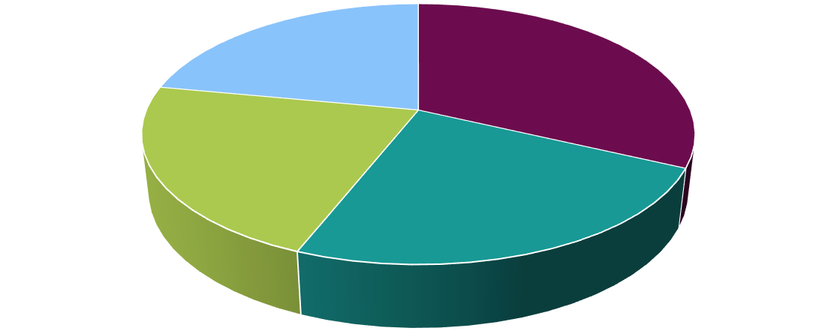
M a r k e t R e s e a r c h . B i z

Chapter 6 South America Polyimide Tape (Kapton Tape) Market Overview

South America Polyimide Tape (Kapton Tape) Market by Product Type

    - South America Polyimide Tape (Kapton Tape) Market Value & Volume Comparison by Product Type (2014-2030)
TABLE 27 South America Polyimide Tape (Kapton Tape) Market Comparison by Product Type (2014-2030)

Product Type | 2014 | 2020 | 2030 | F-CAGR
Silicone-based | XX.X | XX.X | XX.X | X.X%
Acrylic-based | XX.X | XX.X | XX.X | X.X%
Source: Prudour, 2020

South America Polyimide Tape (Kapton Tape) Market Value & Volume Market Share by Product Type in 2020
FIG. 30 South America Polyimide Tape (Kapton Tape) Market Value & Volume Market Share by Product Type in 2020

Source: Prudour, 2020

………. cont’d.

Content has been removed from the sample.

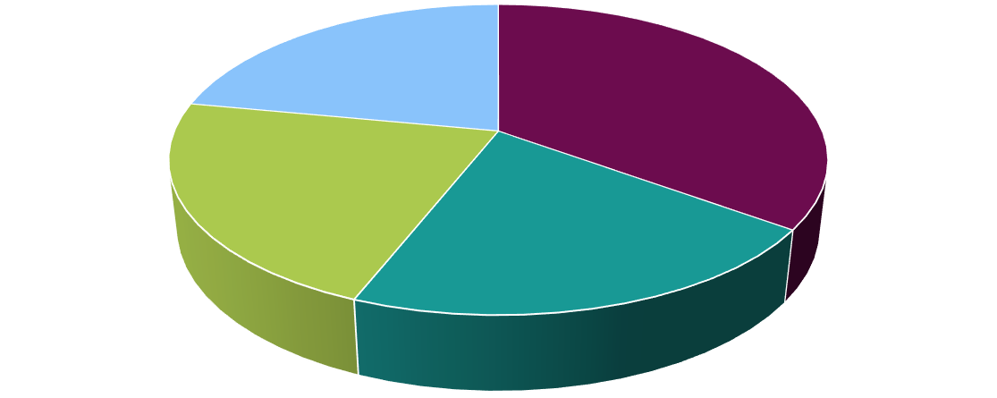
M a r k e t R e s e a r c h . B i z

Chapter 7 MEA Polyimide Tape (Kapton Tape) Market Overview

MEA Polyimide Tape (Kapton Tape) Market by Product Type

    - MEA Polyimide Tape (Kapton Tape) Market Value & Volume Comparison by Product Type (2014-2030)
TABLE 28 MEA Polyimide Tape (Kapton Tape) Market Comparison by Product Type (2014- 2030)

Product Type | 2014 | 2020 | 2030 | F-CAGR
Silicone-based | XX.X | XX.X | XX.X | X.X%
Acrylic-based | XX.X | XX.X | XX.X | X.X%

Source: Prudour, 2020

MEA Polyimide Tape (Kapton Tape) Market Value & Volume Market Share by Product Type in 2020
FIG. 31 MEA Polyimide Tape (Kapton Tape) Market Value & Volume Market Share by Product Type in 2020

Source: Prudour, 2020

………. cont’d.

Content has been removed from the sample.

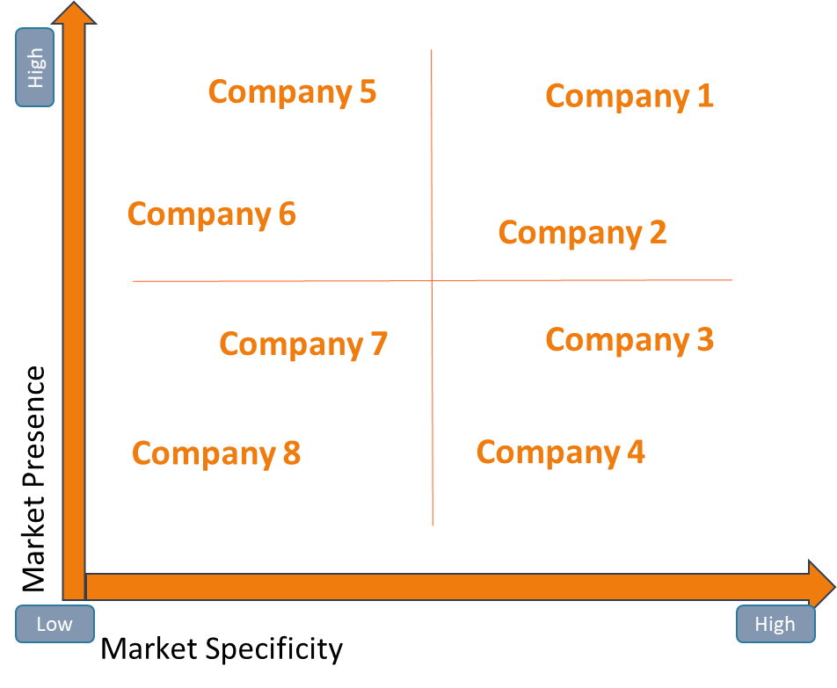
M a r k e t R e s e a r c h . B i z

Chapter 8 Global Polyimide Tape (Kapton Tape) Market Company Profiles

Market Competition Scenario Analysis, By Company

Source: Prudour, 2020

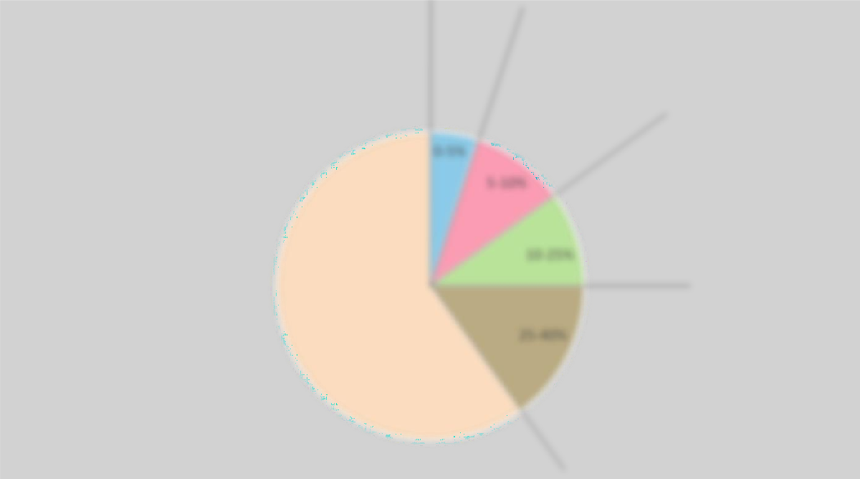
M a r k e t R e s e a r c h . B i z

Competitor Landscape
Company 1

Founded:
Headquarter: Revenue:
No. employees: Business areas: Key Products:

Company 2
Founded:
Headquarter: Revenue:
No. employees: Business areas: Key Products:
Company 3

Founded:
Headquarter: Revenue:
No. employees: Business areas: Key Products:
Company 4

Founded:
Headquarter: Revenue:
No. employees: Business areas: Key Products:
Company 5

Founded:
Headquarter: Revenue:
No. employees: Business areas: Key Products:
Company 6

Founded:
Headquarter: Revenue:
No. employees: Business areas: Key Products:

Source: Prudour, 2020

Company Share Analysis

Source: Prudour, 2020

M a r k e t R e s e a r c h . B i z

Company Profiles

    - 3M Company

      - Company Overview

Establishment Year | XX
Headquarter | XX
Key Management | XX
Value & Volume (US$ Mn) | XX
Headcount | XX
Website | XX

      - Business Description

      - Product Portfolio

Product Segments | Target Product Segments
Content | Content
Content | Content
Content | Content
 | Content
 | Content
 | Content

      - Key Financials

Year | 2017 | 2018
Value & Volume (US$ Mn) | xx | xx
Operating profit(US$ Mn) | xx | xx
Gross Profit (US$ Mn) | xx | xx
Cost Of Sales( US$ Mn) | xx | xx

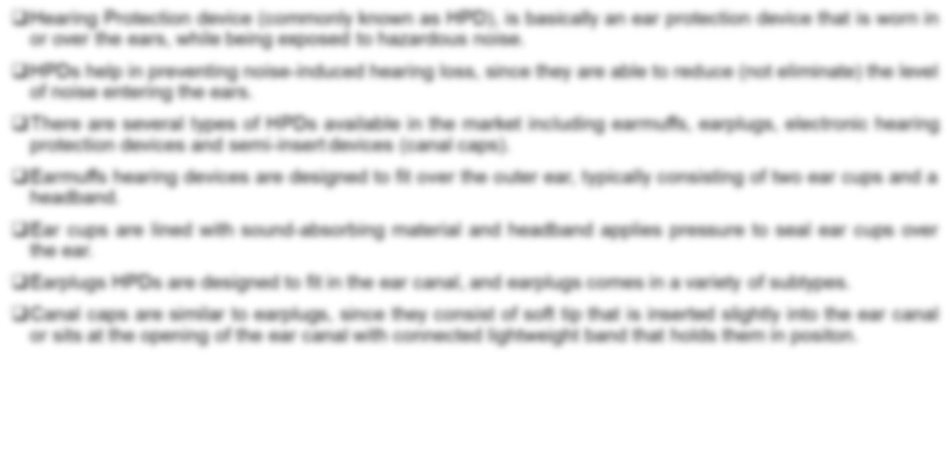
M a r k e t R e s e a r c h . B i z
      - Key Developments

M a r k e t R e s e a r c h . B i z

    - Botron Company Inc.

    - CanDo National Tape

    - E.l. du Pont de Nemours and Company

    - Nitto Denko Corporation

    - Polyonics Inc.

    - Desco Industries

    - Chukoh Chemical Industries, Ltd.

    - DUNMORE

    - ESPI

    - Other Key Players

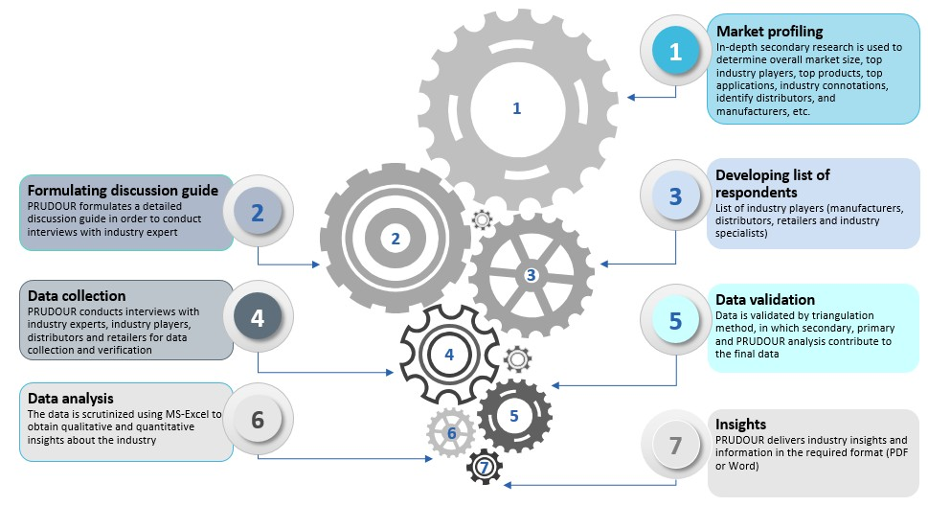
M a r k e t R e s e a r c h . B i z
Chapter 9 Research Methodology

  - Research Methodology

  - Primary Research

Primary research involves e-mail interactions, telephonic interviews as well as face-to-face interviews for each market, category, segment and sub-segment across geographies.

A typical research interview fulfills the following functions:

Provides first-hand information on the market size, market trends, growth trends, competitive landscape, outlook, etc.

Helps in validating and strengthening secondary research findings

Further develops and enhances the analysis team’s expertise and market understanding Participants in this process include, but are not limited to:
Industry participants: CEOs, VPs, marketing/product managers, market intelligence managers, and national sales managers

Purchasing managers, technical experts, suppliers, and traders

M a r k e t R e s e a r c h . B i z

Investment bankers, valuation experts, research analysts specializing in respective industries Key opinion leaders specializing in different platforms of the target industry
  - Secondary Research

Understanding of leading companies in the target markets is supported by a thorough and exhaustive study/research of company press releases, investor presentations, and stock analyst reports etc.

Key players’ product literature, annual reports, press releases, and relevant documents are also studied to conduct a competitive analysis and gain a deeper understanding of the markets, strategies, initiatives etc.

Secondary research includes a search of associations, recent trade statistics, Internet/online sources, and statistical data from government websites and agencies. Findings are then verified through in- depth interviews and discussions with a wide range of key participants and opinion leaders in respective industries.

A major volume of research efforts is through primary research, which is significantly rewarding, trusted, efficient, and effective to gain a clear, crisp, and accurate understanding of the markets

The secondary research sources include, but are not limited to:

Stock analyst websites (Seeking Alpha, Yahoo Finance, Wikinvest, Zacks Investment Research, Factiva, Growth Financial, and others) Company website sources (annual reports, press releases, SEC filings, investor presentations and others)

Journals and other publications

  - Report Scope

The report comprises details of revenue (US$) from the global market for 2020 and offers projections for the next 10 years

Market numbers have been estimated based on demand for the various products, among others. Market size and forecast has been provided in the context of the global, regional, and country-wise markets.

Numbers provided in this report are derived based on demand for the said product/s from different regions and countries (or as per request)

M a r k e t R e s e a r c h . B i z

Prices of products vary from region to region and thus similar volume-to-revenue ratio may not apply (regional average price has been considered in each region as applicable)

General Information

    - This is a general template and is shared to indicate the format, flow, design, presentation, and placement of information, data, and content.

    - The taxonomy should be considered as actual in terms of number of segments, regions etc., this however is not limited, and can be further customized or altered to suit specific requirements (this can be discussed/instructed to the sales team and the same will be provided in a separate/different sample)

    - The tables may contain extra or less number of segments, but this will be changed in the actual/final report, as the tables in the sample are purely for indicative purposes only

    - The sample is purely for demonstrative purposes, and is solely to provide an understanding of the design and placement of data and information in our reports. For more convenience, ask to speak to a research lead for any research-related queries or data, information, sections, slides etc.

    - The design, color, format, template can be changed upon request while placing order or making a purchase

    - Options available in terms of format or End-Use include Power Point Presentation (PPT) or MS Word (the same of which will be shared in PDF format), and can be opted for in advance

    - Customized versions of the report can also be requested for and details shared regarding the requirement

M a r k e t R e s e a r c h . B i z
Chapter 10 About Us

10.1 Who we are:

Prudour (MarketResearch.biz) is a specialized market research, analytics, and solutions company, offering strategic and tactical support to clients for making well-informed business decisions. We are a team of dedicated and impassioned individuals, who believe strongly in giving our very best to what we do and we never back down from any challenge. Prudour offers services such as data mining, information management, and revenue enhancement solutions and suggestions. We cater to industries, individuals, and organizations across the globe, and deliver our offerings in the shortest possible turnaround time. Our ever-growing team of experts and professionals from various streams and verticals bring along crucial tried-and-tested skills, approaches, and techniques to conduct research and analysis, and deliver accurate and reliable forecasts on all global markets. We constantly push the limits and boundaries as we surge ahead to being one among the most sought-after companies in the market research and solutions industry, and this we do with great pride. We never stop focusing on innovation and improvement, which results in significant value addition to our offerings, while at the same time we maintain stringent guidelines with regard to qualitative and quantitative analysis outputs and forecasts.

Prudour offers coverage, analysis, information, statistics, and reports on global as well as regional markets, industries, and sectors and domains, including pharmaceuticals, chemicals and materials, technology and media, food and beverages, packaging, and consumer goods among various others. We offer a 360-degree view of markets and provide accurate forecasts, and also cover competitive landscapes, with detailed market segmentation, key trends, and strategic recommendations to enable our clients to stay ahead of the competition.

We have broadly categorized our offerings into custom market research and syndicated market research reports. Syndicated research reports cover data, information, and analysis on topics or titles that could benefit one or more businesses or individuals. Topics or titles could vary from the macro level of an industry or micro-market level.







M a r k e t R e s e a r c h . B i z

Thank You
To know more about us, please visit our website:
www.marketresearch.biz

For all sales queries or any customized research requirements email us at:
sales@marketresearch.biz or inquiry@marketresearch.biz

For other queries contact:
James Johnson
(General Manager-Business Development)

Tel.: +1 347 826 1876
+91 74474 99707

